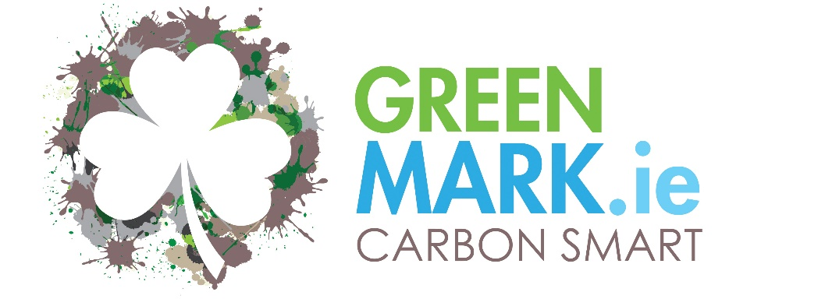

CARBON SMART PLEDGE
ENTER NAME OF Business HERE
This business is delighted to be part of the GreenTravel.ie campaign to reduce the intensity of our Carbon Emissions as set out by the programme.
We have commenced the process to achieve the CARBON SMART GREENMark Standard and we pledge to implement this programme and achieve recognition by ENTER DATE HERE.
We will follow the conditions set to implement and maintain this standard and will publish our performance on an annual basis.

Name of Owner/Manager:
Signature of Owner/Manager

Date:

