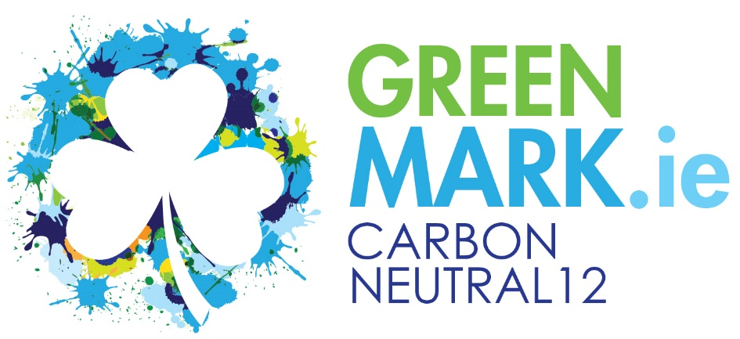
Carbon Neutral
Carbon Neutral, also called carbon neutrality, is a term used to describe the actions of organisations, businesses and individuals taking action to remove as much carbon dioxide from the atmosphere as each put in to it. The overall goal of carbon neutrality is to achieve a zero-carbon footprint.
A Carbon Neutral hospitality business is generally accepted as a business that has measured its Scope 1 & 2 Emissions (Electricity and Fossil Fuels consumed on site) and industry specific Scope 3 Emissions (Business Travel, Laundry impacts, Waste and Water emissions) and achieved a zero-carbon footprint by implementing a Carbon Reduction programme, Reducing energy consumption, investing in renewables and offsetting their net carbon footprint, if necessary
The GREENMark recognises that many businesses are interested in achieving this status and has created the Carbon Neutral12 GREENMark as a standard to enable businesses to achieve this and promote their actions to consumers.
Carbon Neutral12 GREENMark
The Carbon Neutral12 GREENMark can only be awarded to a business that has achieved the Carbon Smart GREENMark and has demonstrated a sustained approach to energy efficiency within their property.
Achieving Carbon Neutral12 status is not possible by simply buying green energy and/or offsetting carbon footprints. Businesses must have an ongoing carbon/energy reduction plan and must be able to show how they have reduced their energy/carbon intensity/consumption over a sustained period – at least 3 years prior to a GREENMark application.
A Carbon/Energy Management plan must also be in place showing what steps the organisation is taking to continue reducing their energy intensity – which leads to a lower carbon footprint.
The GREENMark accepts the principle of Green Electricity as approved by SEAI and allows carbon offsetting from GREENMark approved programmes.

It is not the intention of the GREENMark at this time to create a model where the carbon footprint of all goods and services (Scope 3) need to be calculated as the medium-term objective is for each supplier to achieve carbon neutrality which would therefore render goods and services supplied as carbon neutral.
However, the Carbon Neutral12 GREENMark businesses must include in their Purchasing Policy a stated preference for suppliers to have achieved Scope 1 & 2 carbon neutrality. They must give this a weighting that would be advantageous for the supplier as part of their competitive quote.
The purchasing policy must also prefer locally supplied goods (Of Irish Provenance) and services and actively source these which will result in reduced travel miles.

Carbon Offsets
Businesses may offset their carbon footprint by purchasing renewable energy directly (e.g.; Green Electricity) and/or by purchasing carbon offsets.
Carbon Offsets are only acceptable from projects based on the Island of Ireland and the business must be able to provide certificates for these offsets to prove their provenance, purchase and subsequent retirement. (The Green Trading Company operates a Carbon Offset programme which will deliver these certificates)
Where carbon offsets from forestry are being claimed these are only accepted from Native Irish Woodland plantations which either belong to an internationally accredited offset programme or have been recognised as such by GREENMark.
All Carbon Offsets claimed must be approved, in advance, by the GREENMark, and the GREENMark reserves the absolute right to refuse to accept the offset request. (This forms part of the Terms & Conditions of joining the programme)

Achieving the Carbon Neutral12 GREENMark
The following conditions must be met;
Must have achieved the Carbon Smart GREENMark.
Must have a Carbon Reduction Plan which must include the following;
- Identify energy efficiency actions taken and how they will be maintained
- A list of energy efficient actions that will reduce total energy consumption by 5% per annum
- Annual Benchmarking and KPI analysis provided
- Must include the Carbon Emissions from the businesses corporate travel and laundry operation (Businesses can use the Hotel Carbon Measurement Initiative methodology to calculate these where laundry is managed off site)
Where the business is applying Carbon Offsetting or purchasing renewable energy full details of these must be provided.
Must publish on their website complete details of their Carbon Reduction Plan – identifying projects undertaken, energy efficiency achievements and how they are achieving carbon neutrality.
Must include within their Purchasing Policy a commitment to
- Prefer suppliers that are also engaged in Carbon Reduction programmes – focusing on Scope 1&2 emissions
- Prefer suppliers that operate their business in an environmentally responsible manner
Must provide GREENMark with the required information annually to maintain their Carbon Neutral12 status.
Must accept the terms and conditions

Carbon Neutral12 GREENMark

Programme Costs
Programme setup
- Review of Carbon Reduction Plan
- Review of Carbon Footprint claims
- Verification of renewable energy, carbon offsets, etc.
- Review of updated Green Purchasing Policy showing how suppliers with low carbon footprints are preferred
- Website review
€ 750 per property
Annual Membership
Included within your Carbon Smart GREENMark membership which must be reported on annually.

