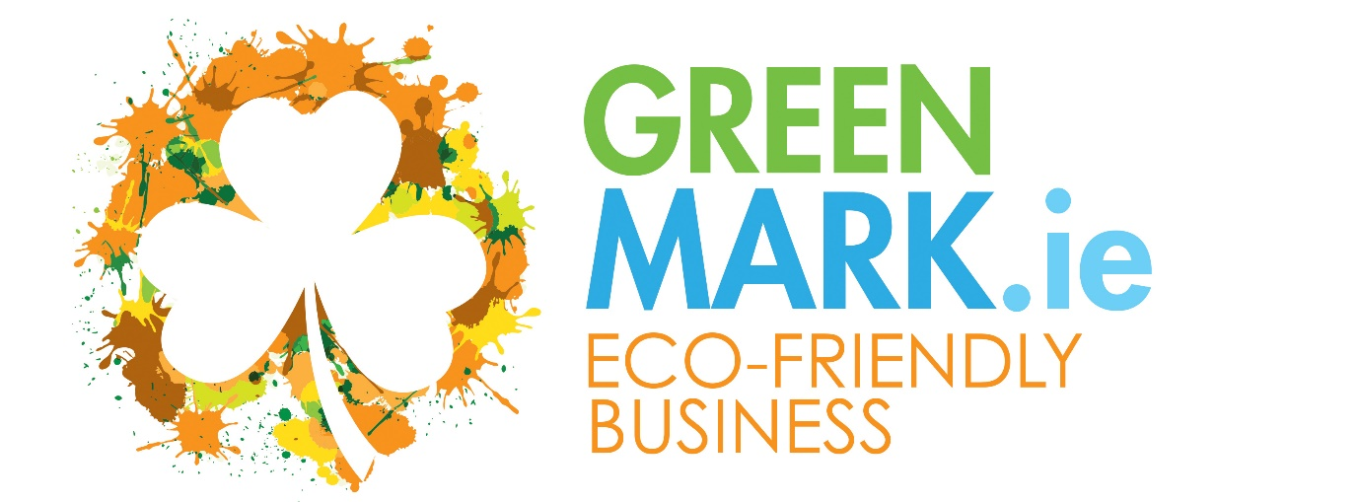

An Environmental Recognition Programme for smaller Tourism & Hospitality Businesses

Application Form

Eco-Friendly Business GREENMark
Recognised Business Programme

Green Hospitality recognises the challenges facing many businesses and understands that environmental certification or membership of another programme may be too costly at present or does not fit within the current business model and so, we have developed a recognition model designed to support your business in being able to state that you operate in a sustainable manner – and one that can easily be converted into a Recognised Status with additional marketing opportunities.
The Eco-Friendly Business GREENMark is a “light” environmental programme, focusing on energy, water and waste, that requires you to undertake a number of direct actions that will incorporate sustainability into your day-to-day operation.
You have decided that you wish to be formally recognised and achieve the GREENMark
I am interested in achieving the Eco-Friendly Business GREENMark. What do I do next?
Make sure you have achieved 100% on the Green Track – meaning you have implemented all the required standards (If you are looking for additional assistance send us an email setting out what supports you need and we will be in touch – info@greenhospitality.ie )
Apply using the application form enclosed.
We will raise an initial registration and audit invoice for €299 plus VAT @ 23%.
Once you have paid the initial invoice, we will onboard you to our platform and then, if you are ready, conduct a Desk Audit and deliver a Quality Score.
If you do not achieve the required % you will receive an audit report identifying where you need to improve and will be entitled to a follow up desk audit on the standards highlighted – success will lead to recognition
If you fail to achieve recognition after the 2nd desk audit and wish to proceed you will be required to pay an additional registration and audit fee of €299
Following a successful audit we will advise you and ask that you pay your first years membership fee through our online shop.
On receipt of payment we will issue you with your certificate and logo and provide a marketing document to enable you to be listed within GreenTravel.ie
(The Eco-friendly business GREENMark is only available for businesses with Annual Utility Costs of less than €75,000 per annum. Businesses with spends of over €75,000 who require support/certification should become a Green Hospitality Programme member – find us at www.greenhospitality.ie)
Eco-Friendly Business GREENMark
Annual Membership Costs
Size of Business | Explanation | Annual Cost*
Micro | B&B’s and small self-catering operations, Activity providers and smaller attractions, Artisan food producers, artisan craft producers, others, etc.  (Spends less than €10,000 pa on utilities) | € 99
Small | Guesthouse, Hostel, Restaurant, Pub – Larger self-catering, Activity/Attraction providers, local attractions, others, etc. (Spends less than €25,000 pa on utilities) | €149
Medium | Larger guesthouses & hostels, self-catering villages and camping sites, larger attractions and activity providers and Regional Attractions, Others, etc. (Spends less than €50,000 pa) | €199
Larger | Larger accommodation providers and larger attractions – Small Hotels, Hostels, large self-catering and camping sites – Attractions of a National scale, Green Tour Operators, others, etc.  (Spends less than €75,000 pa on utilities) | €299

*(Pricing is based on total annual utility costs - The total cost of your Energy, water and waste – excluding Destinations and Tour Operators)
(Businesses that spend more than €75,000 pa on utilities should contact us to discuss serious cost saving opportunities and should be planning to achieve certification through the Green Hospitality Programme)
VAT @ the current rate will be added
Prices are for one year’s listing and are payable annually to retain the GREENMark and must be paid through our Online Shop.
Whilst the business explanations above mention specific types of tourism and hospitality businesses, this programme is open to all businesses that wish to be recognised for their environmental activities and can also be an entry point to the Green Hospitality Awards certification.
Fáilte Ireland Registration. Where a national registration scheme is in place only those businesses that are registered can be listed in GreenTravel.ie

APPLICATION FORM
I wish to apply for the the Eco-Friendly Business GREENMark
Business Details:
Name of Business:
Name of Owner/ Manager:
Email:
Type of Business:
Address:

Website:
How much do you spend each year on Energy, Water and Waste Disposal? €

Your Name:
Your Email:
Your Position:
Signature : _________________________________________________________
Date:
PO Number: (If Required):

SEND THIS COMPLETED FORM TO: INFO@GREENHOSPITALITY.IE

Terms & Conditions
- Companies must provide GHP with required marketing information
- Payment of the annual fee must be made within 30 days of its due date and must be paid online.
- Each business will commit to operating their business in an environmentally and responsible manner and to maintain the standards set by the GREENMark.
- Conditions may vary from time to time and will be noted on the GREENMark webpages.

Green Hospitality Programme reserves the absolute right to refuse any business a listing and to remove any business listed if GHP considers the business is not providing or delivering a sustainable or environmentally beneficial product/service. By applying for a listing companies fully accept these terms and conditions and any changes GHP may make to those Terms & Conditions at any time. Businesses may ask for their product/service to be removed from GreenTravel.ie at any time – no refunds are possible.
All GreenTravel.ie listed businesses will be required to pay annual subscription fees online through the www.greenhospitality.ie ecommerce shop – formal VAT receipts will be issued to all.

