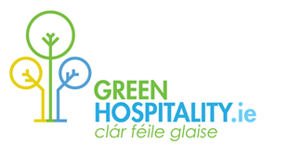
Green Hospitality Awards

Environmental & Sustainability Certification & Resource Efficiency Programme for the Irish Tourism & Hospitality Sector

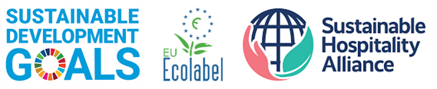

Aligned with the UN Sustainable Development Goals, Global Sustainable Tourism Council Criteria, EU Ecolabel and the Sustainability Hospitality Alliance Hotel Carbon, Water & Waste Measurement Methodologies

www.greenhospitality.ie
Valid to 31/12/2022

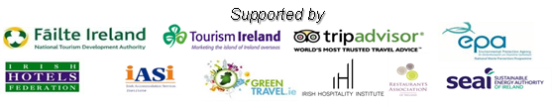
Green Hospitality – Programme and Services

Green Hospitality (GHP) is the Irish Hospitality, Travel & Tourism Resource for Sustainable and Responsible Tourism. GHP’s objective is to support the Irish Hospitality sectors drive to improve its Environmental & Sustainability performance by providing certification, recognition, promotion, resource efficiency & consulting services.

CERTIFICATION
Green Hospitality Awards. Our internationally recognised Third-party Environmental & Sustainability Certification Awards Programme. It is aligned with the UN Sustainable Development Goals (SDGs), Global Sustainable Tourism Council (GSTC) criteria, EU Ecolabel and the Sustainability Hospitality Alliance Hotel Carbon, Water & Waste Measurement Methodologies.
Hospitality businesses that wish to be recognised for their environmental and sustainability actions, required by clients to demonstrate these actions or who wish to gain competitive advantage by promoting their environmental & sustainability credentials will aim to achieve certification – cost saving accompanies environmental programme implementation.

RECOGNITION
GREENMark Eco-friendly Business. For Micro and Small businesses, we provide a simpler approach that enables them to be recognised for their environmental actions – micro-certification. This can be a good base to prepare for full certification or in its own right.

PROMOTION
GreenTravel.ie - Our consumer website promotes environmentally sustainable tourism businesses to visitors and tourists. A listing on this website is open to all tourism/hospitality businesses that have achieved any environmental or sustainability certification or approval that is recognised by GHP.

CONSULTING – Certification Support, Resource Efficiency, Benchmarking, Carbon Footprint, Training, Cost Saving
Green Trading Company. GTC offers a range on services that can operate on their own or to support and complement the Green Hospitality Award programme.
Our core services include - Certification Support Programme, Benchmarking & KPI analysis, Carbon Footprinting, Resource Efficiency Health Check (Energy, Water, Waste), Micro-certification, Employee training, on-site environmental consulting, etc. – with a consistent focus on cost saving.

Green Hospitality Award Programme - Certification
Eco-label, Silver, Gold & Platinum

Our internationally recognised Third-party Environmental & Sustainability Certification Programme. It is aligned with the UN Sustainable Development Goals (SDGs), Global Sustainable Tourism Council (GSTC) criteria, EU Ecolabel and the Sustainability Hospitality Alliance Hotel Carbon, Water & Waste Measurement Methodologies and focuses on the implementation of an Environmental Management System with detailed performance and actions relating to Energy, Water & Waste Management followed by social & economic sustainability pillars.

The Programme is designed as a Step-by-Step approach allowing businesses implement the required criteria at their own pace and initially embed environmental sustainability as part of their business model whilst they build towards the full sustainability award. The Eco-label Award is the first step for the built environment. The Silver and Gold Awards build on the Eco-label criteria whilst supporting additional sustainability and savings initiatives within the business and the Platinum Award incorporates Corporate Social Responsibility, sustainability and deeper environmental actions

Key Benefits. By becoming a GHP Member you are entitled to the following benefits.

- Access to all GHP Tools, Templates, Checklists, etc.
- Benchmark & KPI Workbook - use of our Benchmarking Tool
- Use of the GHP Logos allowing for national/international promotion
- Free Entry to GreenTravel.ie – the GHP online travel & tourism website
- Access to the GHP Resource Database and regular information updates
- Discounted or Free access to GHP training, workshops, conferences, etc.

Specific Conditions: Maintaining certification to any of the GHP award standards requires on-going verification through our online Green Folder and either an annual site visit or a formal on-site audit at least once every three years.

Certified members are required to commit to a minimum of three years membership and Awards are only valid for businesses that are current fully paid-up programme members.

Certification audits will be charged for, unless included within a membership package. Members pay an annual fee based on their Utility Costs.

GHP Membership - Getting Started

All new members commence their initial year on our GREENSave Initial Membership package – no matter their size. This service, which includes the first year’s membership fee, provides online support to enable GHP to present to the member the programme administration, key tools and templates, and provides additional support where required. (Our Enhanced Package includes a Site Visit)
Should you wish additional support our sister organisation – Green Trading Company (GTC) – provides services designed to enable your business achieve certification quickly, or other sustainability actions.
Green Trading Company
GREENStart
Certification Support, Benchmarking and
Resource Efficiency Health Check
These GREENStart packages are designed to provide additional support for the Green Hospitality Awards Certification programme or can be delivered on a stand-alone basis.

GTC offers 3 GREENStart Services.
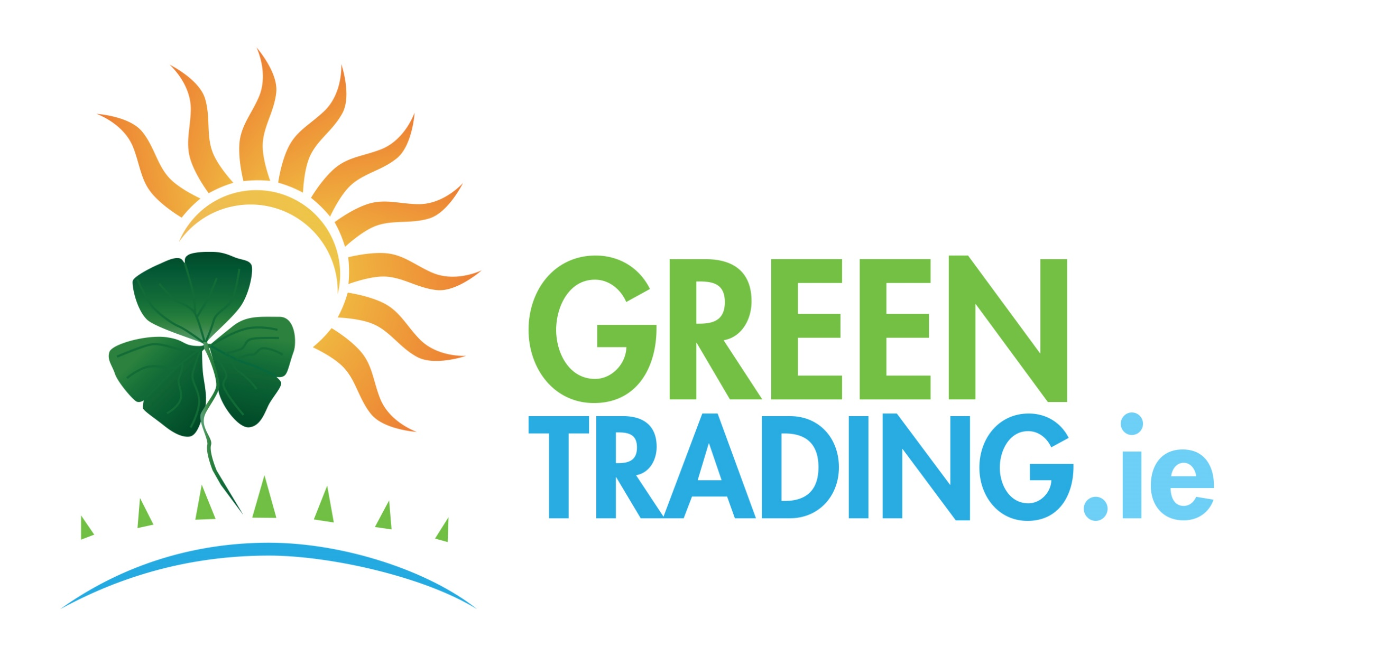

Certification Support Service
Benchmarking, KPI’s and Carbon Footprinting
Resource Efficiency Health Check
Certification Support Service

GTC will work with the business to achieve the Green Hospitality Eco-Label Award – By the end of the service the business will have achieved 100% of the Mandatory Eco-label criteria to a Quality Score of 3 (Subject to client engagement) The service includes;

- Benchmarking, KPI’s and Carbon Footprinting to the SHA Standard
- Resource Efficiency Health Check service
- Online and site visit support for Green Leader/Team
- Eco-label criteria implementation and award application

Benchmarking Support Service / Carbon Footprint Verification

GTC will create a baseline year benchmark workbook using the GHP Benchmark Workbook. (Subject to business providing the required data)

The Service includes; Baseline Year benchmarking, Carbon Footprinting to SHA standard – verified, KPI analysis – including MRSO (Where data is available) – The Carbon Footprint Verification service will enable the business to declare its Carbon Footprint and Calculations as 3rd party verified calculations

GTC also offers a Monthly or Quarterly Benchmark Service with regular reviews of a businesses KPI’s.

Resource Efficiency Health Check
Includes a detailed review of the Resource Efficiency KPI’s of the business. (Subject to the business having completed a Benchmark Workbook)
Additionally, a Resource Efficiency walk through of the site will be undertaken with the intent to identify specific resource efficiency opportunities, focusing on no and low-cost actions.

If you want more information on any of these services or would like to discuss other sustainability supports please complete the expression of interest and return it to us.
Use the Application/Expression of interest form if you are interested in any of these services.
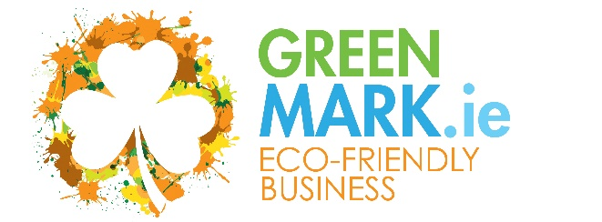  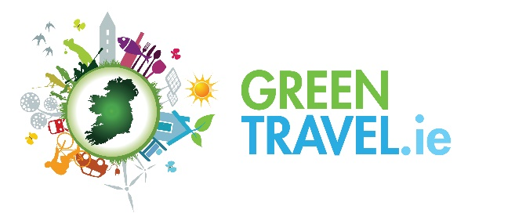 | RECOGNITION  The Eco-friendly Business GREENMark is our recognition programme to enable smaller hospitality businesses, attractions, activities, etc. secure recognition for their sustainable activities – where formal certification is either too onerous, costly, or not relevant  PROMOTION  GreenTravel.ie is Irelands Sustainable Hospitality website where we bring together all sustainable businesses across Ireland – either certified or recognised for their sustainable activities.  It is free for GHP Certified or GREENMark Eco-Friendly businesses. www.greentravel.ie
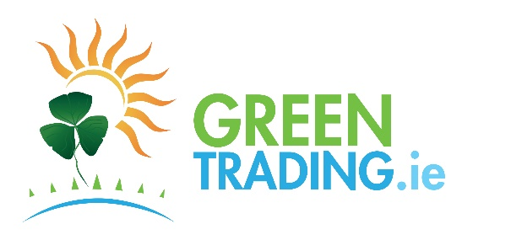 | RESOURCE EFFICIENCY, CONSULTING, TRAINING, MICRO CERTIFICATION  The Green Trading Company provides Resource Efficiency (Energy, Water, Waste), Consulting, Training, and a number of other services to businesses. The focus is on cost savings.  Services include: GREENClean, GREENFootprint, GREENEnergy, GREENWater, GREENWaste.
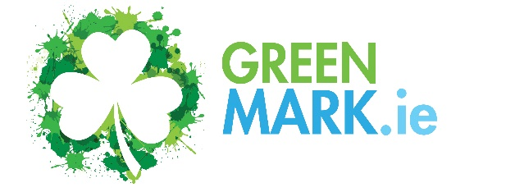 | Micro Certification – For businesses that wish to achieve additional recognition, or to focus on specific actions – Plastic Smart, Energy/Carbon Smart, Carbon Neutral12, Allergy Friendly Smart, Water Smart, Waste Smart. Can operate standalone or build towards certification.

Membership Fees and Packages

 | GREENSave  Initial Membership | GREENSave – Annual Membership Fees
 |  | Standard Membership | Support Package | Enhanced Package
Utility Costs | Standard/Enhanced | (Limited direct support) | (Standard Membership plus Online Support & Desk Audit) | (Support Package plus Annual Site Visit)
Under € 75,000 | €995/€1,500 | €595 | €795 | €1,500
Under €150,000 | €995/€1,500 | €595 | €795 | €1,500
Under €300,000 | €995/€1,500 | €795 | €895 | €1,500
Over €300,000 | €995/€1,500 | €795 | €895 | €1,500
VAT @ current rate will be charged. Payment conditions apply. All New members commence with a GREENSave Initial Membership Package.
Utility Costs – Total Annual Costs of Energy, Water (Supply/Disposal) plus Waste Costs (Net of VAT)
Certification – A Desk Audit is required for any business to achieve any certification level followed by a Site Visit to verify compliance for Silver, Gold and Platinum Awards. (Desk Audit - €500 (Included in Support & Enhanced Packages), Silver/Gold Award Verification/Site visit - €750 (Included in Enhanced Package) – Platinum Award Desk Audit & Site Visit Verification - €1,500)
All GREENSave packages require a minimum 3-year membership commitment. All members must give 6 months’ notice of membership cancellation prior to the current membership package end date – membership packages automatically renew unless cancelled. All members are automatically bound by the GreenHospitality.ie general terms and conditions which are found in the GHP website on payment of their 1st years fee.
It is required that accommodation providers on any GREENSave package will also provide overnight accommodation and subsistence for each site visit to enable a thorough property assessment. Where travel exceeds 100km a mileage charge will be applied.

Green Hospitality Programme
GREENSave Membership Packages
Initial Membership
Includes: Onboarding to the Programme, 1 years Membership, GHP Benchmark Workbook, Online Green Folder, Online GHP Training and Workshops. Access to members section of GH website. Member Discounts on specified GHP sustainability programmes. Where applicable/certified – use of GH Award Logos, certificate, Listing in GreenTravel.ie, Ability to list as a Green/Sustainable business in third-party websites.
Initial Desk Audit - Verification Site Visits are additional costs – Site Visit support service available
Annual Membership - Standard
Includes: Annual Membership, GHP Benchmark Workbook, Online Green Folder, Online GHP Training and Workshops. Access to members section of GH website. Member Discounts on specified GHP sustainability programmes. Where applicable/certified – use of GH Award Logos, Certificate, Listing in GreenTravel.ie, Ability to list as a Green/Sustainable business in third-party websites.
Desk Audits and Verification Site Visits are additional costs
Annual Membership – Support Package
Includes: Standard Membership features
Online resource efficiency support (Energy, water, raw materials, waste), subject to limits.
An annual Desk Audit is included, if required – Verification Site Visit is an additional cost.
Annual Membership – Enhanced Package
Includes: Annual Membership Support Package
Annual Desk Audit included, if required.
Annual Site Visit – to review/support environmental programme, verify certification, resource efficiency support. (Excluding Platinum Award Audit & Verification)
(Additional site visits can be delivered – if required, please discuss with GHP)

Application/Expression of Interest (Cross one Out)

Company Name

Type of Business
Address

Annual Cost of Utilities – (Energy, Waste & Water) | €
Package Required  Circle/Mark/Identify the package / programmes you are interested in. | GREENSave – GHP Certification Membership  - Initial Membership  - Standard  - Enhanced  - Standard Membership  - Support Package Membership  - Enhanced Package Membership  Other (Specify):
PO Number:
Telephone
Your Name
Your Position
Your Email Address
Signature

Date

Please complete this form and send it to GreenHospitality.ie, Eastgate Village, Little Island, Cork. T45 A363 or email it to info@greenhospitality.ie

