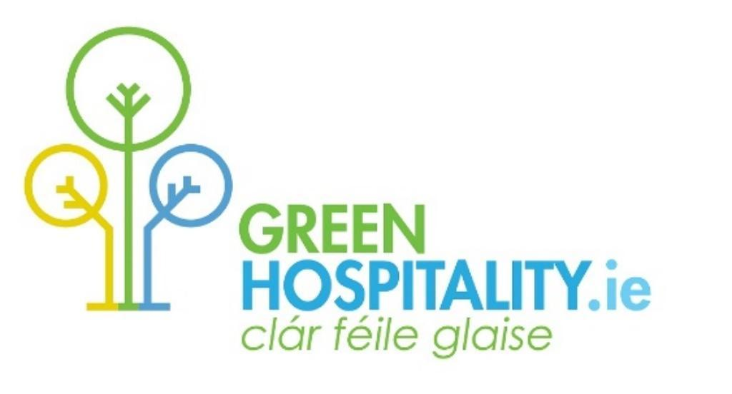

Award Certification
Criteria

All Hospitality Businesses
(Version 13.8 – May 2023)

Supporting
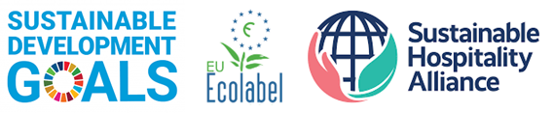

G:\My Drive\Temporary Files\GHP Master Documents\Green Hospitality Awards - Criteria-V13.8 - May 2023.docx

The Green Hospitality Awards are environmental and sustainability certification awards designed to support hospitality and tourism businesses implement an environmental and sustainability management programme and which also enable them to promote these credentials to customers and stakeholders. The programme is designed for larger tourism businesses, mainly hotels, and those with annual utility expenditure more than €75-100,000.

The awards programme supports the UN Sustainable Development Goals (UN SDG’s), is aligned with the Global Sustainable Tourism Council Criteria (GSTC) and uses the Sustainable Hospitality Alliance (SHA) measurement methodologies for Energy, Water and Waste

The Eco-Label Award is our entry level programme which focuses on implementing an environmental management system within the business and provides a strong platform for adding additional environmental good practices.

The Silver and Gold Awards require additional implementation of environmental criteria, both mandatory and optional, which embeds a deeper environmental process within the business.

The Platinum Award combines Best Practice Environmental Management along with wider Sustainability Actions, is aligned with the GSTC Criteria, and delivers a broad Sustainability Award.

The Green Hospitality Awards are Type 1 Eco-Labels, based on life-cycle analysis that are third-party audited.

Small Hospitality Businesses

Our Eco-Friendly Business GREENMark - smaller hospitality and tourism businesses, who are not part of a recognised certification or sustainability programme, who wish to be recognised for their environmental and sustainable activities but do not wish to go down the certification route, can be listed on the GreenTravel.ie website by achieving the Eco-Friendly Business GREENMark - a light Eco-Label (contact info@greenhospitality.ie for more information or find more details on the GreenHospitality.ie website)

This version has been updated May 2023

Global Standards – Our Alignments

The Sustainable Development Goals are a universal call to action to end poverty, protect the planet and improve the lives and prospects of everyone, everywhere. The 17 Goals were adopted by all UN Member States in 2015, as part of the 2030 Agenda for Sustainable Development which set out a 15-year plan to achieve the Goals.

We have identified the SDG’s our criteria support, where applicable, and encourage members to communicate this to their stakeholders. Tourism businesses generally focus on Goals 6, 7, 11, 12, 13, 14 & 15

The Sustainable Hospitality Alliance brings together engaged hospitality companies and uses the collective power of the industry to deliver impact locally and on a global scale.

The SHA have produced 3 tools to deliver a worldwide consistent methodology to measure a hotels environmental impact for Carbon/ Energy, Water and Waste. GHP members receive benchmarking tools that follow these methodologies.

The EU Ecolabel is the official European Union voluntary label for environmental excellence. Established in 1992 and recognised across Europe and worldwide, the EU Ecolabel certifies products with a guaranteed, independently-verified low environmental impact

The Green Hospitality Awards are aligned with the EU Ecolabel criteria, particularly the Eco-Label, Silver and Gold Awards

The Global Sustainable Tourism Council® (GSTC) establishes and manages global standards for sustainable travel and tourism, known as the GSTC Criteria.

They are arranged in four pillars: (A) Sustainable management; (B) Socioeconomic impacts; (C) Cultural impacts; and (D) Environmental impacts. Since tourism destinations each have their own culture, environment, customs, and laws, the Criteria are designed to be adapted to local conditions and supplemented by additional criteria for the specific location and activity.

The Green Hospitality Awards are aligned with these Criteria with the Eco-Label, Silver & Gold Awards primarily delivering on the Environmental Pillar and the Platinum Award focusing on the other 3 pillars.

Our Awards Process

The certification programme is designed to be completely online. Once a member joins, they will be assigned an online Green Folder where they are required to store all the evidence required to show how they have implemented the criteria relevant for each award level.

GHP also operates an online Members Resource Area which has a certification section that includes programme and criterion guides, tools, templates, good practice application, training videos, etc.

GHP also provides each member with a number of key working documents which can be used to support the programme. These include;
- Green Check – our certification tracker (Mandatory)
- Waste Tracker – our waste measurement tool
- Benchmark Data Tracker – Energy & Water measurement tool

Depending on the membership category selected, members may have additional support from GHP experts to assist in the certification implementation and Online Green Folder management.

Annual Returns

Each certification level is valid for a 3-year period subject to a number of conditions;

- Achieving the required Eco-Label Quality % score
- Member paying the annual fee
- Member maintaining the criteria for the certification level attained
- Member makes an annual return
- Member provides GHP with annual Benchmark Data

Promotion

Achieving certification enables a member to declare publicly that they are 3rd party environmentally/sustainability certified, which brings additional competitive advantage opportunities. This can be done through their own websites and marketing efforts as well as through other agencies. This is particularly important for RFP’s and MICE clients.

More and more booking engines and referral websites are highlighting responsible businesses and they generally require the business to be 3rd party certified. These include; Convention Bureaus, Booking.com, Google, Expedia, etc.

Green Hospitality Certification Awards

The Eco-Label Award is our entry level programme which focuses on implementing an environmental management system within the business and provides a strong platform for adding additional environmental good practices.

Eco-Label Award members will undergo an online audit.

The Silver and Gold Awards require additional implementation of environmental criteria, both mandatory and optional, which embeds a deeper environmental process within the business.

At this point members are also required to implement several additional criteria to broaden and expand their environmental approach. We recommend that a strong focus is placed on energy/carbon actions as these come strongly into play for the Platinum Award.

The quality of the Eco-Label must achieve an average score of 60% to achieve the Silver Award and 75% for the Gold Award – this highlights the importance of starting with an excellent Eco-Label.

Silver & Gold Award members will undergo an online audit initially, followed by an on-site verification audit. (This will be charged for unless it is included in a members annual membership fee)

The Platinum Award combines Best Practice Environmental Management along with wider Sustainability Actions, is fully aligned with the GSTC Criteria, and delivers a broad Sustainability Award.

A member cannot achieve the Platinum Award unless they have already secured the Gold Award – and held it for at least 1 year.

The quality of the Eco-Label criteria must achieve an average score of 80% to achieve the Platinum Award.

Platinum Award members will undergo an online audit initially, followed by an intensive on-site verification audit. (This will be charged for unless it is included in a members annual membership fee)

All Certification candidates:

Each business should initially focus on the Eco-label Award criteria and implement them within their daily operation to a very high standard.

This element of the programme is vital as a strong initial implementation of mandatory criteria will allow the business to achieve Certification and maintain it into the future and set the framework to achieve higher awards. There is an increasing quality score applied to the Eco-Label annually and as a member progress to higher award levels.

At the same time members should review all criteria – Mandatory and Additional/Optional – for all awards and identify where they wish to be and in what timeframe and how they should build additional criterion into their current action plans to achieve higher award status.

Once the Eco-Label has been achieved, we recommend that members work towards Silver and then Gold and ultimately the Platinum Award is the final step.

If the Platinum Award is the target, then every criterion at every award level must achieve a very high standard at the implementation stage – and the member must achieve the Gold Award first before Platinum can be applied for.

Mandatory requirements

Eco-Label mandatory requirements are weighted towards the implementation of a strong Environmental Management System within the business.

Silver & Gold build on these whilst Platinum deepens them and adds a set of broad sustainability criteria

Additional Criteria

Additional Criteria are required for all Awards above the Eco-Label, and increase in number. Members can choose these from the Additional/Optional List provided by GHP or choose their own actions.

Whilst there are a minimum number of additional criteria required from Gold upwards, we encourage members not to see this as the Goal, but as an initial target. All members should focus on implementing as many good practice environmental and sustainability actions they can, as it improves their performance – financially, environmentally and in terms of sustainability.

Quality Assessment

For members wishing to achieve any Green Hospitality Award they must achieve a specified Quality Score. This is a combination of an overall % for the Eco-Label and individual criterion scores.

Audits

GHP members wishing to achieve any Award level must undertake a certification audit. Eco-Label candidates will be audited online through a Desk Audit

Silver/Gold and Platinum awards will receive a desk audit initially followed by an onsite verification audit – an additional fee may be charged.

Desk Audits will immediately cease should GHP note that the Eco-Label criteria have not achieved the required minimum % Quality Score required for each award level. A re-audit fee may be charged in these circumstances.

Verification Process

There is a guide to each criterion within each member’s online Green Folder.

Each criterion has a verification sheet which can be used to describe how each one has been implemented.

All documentation must be saved online in the member’s Green Folder. Failure to maintain sufficient backup may lead to an Award being withdrawn or not awarded.

It is a requirement that sufficient backup information is provided within each criterion sub-folder sufficient to enable a 3rd party to see online how a criterion has been implemented by way of photograph, invoice, contract, checklist, or other documentation and that a written statement will only be accepted when there is no other way to show how a criterion has been achieved. This is designed to ensure the online green folder outlives the properties Green Leader and GHP auditor(s).

Members are encouraged to be comprehensive in their verification information

Required Criteria for Award Certification

To achieve any Green Hospitality Award, a business must implement and be able to demonstrate that it is in compliance with a set of criteria. These criteria are split into Mandatory and Additional.

- Mandatory – all these criteria must be implemented to achieve each certification level
- Additional – a certain number of other actions must also be adopted and implemented
- Quality Score – A Quality Score is applied to each criterion during the audit process and this increases as the member aims for higher awards. The average quality of the Eco-Label criteria must achieve the targets set – which means members should focus on initially implementing a Best Practice Eco-Label

 | Total Mandatory Criteria Required | Total Additional  Criteria  Required | Minimum Eco-Label Quality Score
Award - Eco-Label | 24/31 | 0 | 40-60%
Award – Silver | 45/52 | 20 | 60%
Award – Gold | 67/74 | 25 | 75%
Award – Platinum | 96/103 | 25 | 80%

The number of mandatory criteria varies depending on the type of business – some criteria are not applicable for some business types, more can be applicable equally.

Please note that as each level of the Award is achieved ALL the mandatory criteria must be achieved within each level below and the Eco-Label must be improved in quality terms.

Please note that the layout of the Award criteria following includes a yes/No column. This is provided to enable the business to conduct a quick in-house assessment of where they stand – Use Y/N as you read down through the criteria with Y meaning – Yes, we have this in place or it is easily achieved - and N meaning - No, this is not in place and will require some work
You may be surprised to identify how many criteria are already in place within your business!

Eco-label – Mandatory Criteria

No | Environmental Management System (EMS) | GSTC | Ref | SDGs | YES/NO
Commitment & Compliance
1 | Green Hospitality Charter. Member has read and signed the GHP Programme Charter |  | EMS/1 | 8.9
2 | Regulatory Compliance. Member has signed the environmental legislation declaration and is compliant with the relevant legislation |  | EMS/2
3 | Local Authority Compliance. Member is compliant with any specific environmental improvement requirement made by their Local Authority and has declared as such |  | EMS/3

Leadership, Training & Administration |  | GSTC | Ref | SDGs | YES/NO
4 | Green Team. Appoint a Green Leader, supported as required by a Green Team, and show how the green programme is embedded within the business’s personnel/HR structure | A.4 | EMS/4 | 8.9
5 | Training. Provide sufficient training to ensure all staff have the required knowledge and skills to maintain the programme. Deliver refresher training annually. | A.4 | EMS/7 | 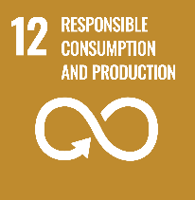  12.8
6 | Green Folder(s). Maintain verification data and backup in your online folder to demonstrate compliance with the required criteria and review/update at least annually | A.1 | EMS/8 | 12.6

Measuring & Monitoring
7 | Data Collation. Collect data on the business’s environmental impacts – waste, water, and energy/CO2 - at least annually.  Provide annual data to GHP. | D.1.3 – D.1.4 – D.2.1 – D.2.4 | EMS/5 | 12.6 - 12.b

Identification, Planning, Policy |  | GSTC | Ref | SDGs | YES/NO
8 | Environmental Policy. Has a written environmental policy for the business which includes quantifiable targets and is updated annually |  | EMS/6 | 12.6  (13.2)
9 | Opportunity List/Action Plan. Conduct an overall review of your business and create a list of the environmental actions and improvements you could undertake and then identify which actions you will implement during the next year. (An Opportunity List and Action Plan). |  | EMS/9 | 12.b

Communication and Marketing |  | GSTC | Ref | SDGs | YES/NO
10 | Marketing Data. Provide property marketing data for inclusion within GHP websites using the GHP Template |  | EMS/28
11 | Internal Communication. Incorporate your Green Policy, Actions and Targets, into literature and communication channels – for all stakeholders.  Member must be able to show how the customers are invited to support the organisations environmental and sustainability policies, particularly within guest bedrooms, which must include clear guidance on the actions customers could take. | A.6 | EMS/38
12 | Public Transport. Provide information in advance on how to access the business using public transport and alternative transport and EV charging - for all stakeholders. | D.2.2 | SR/3 | 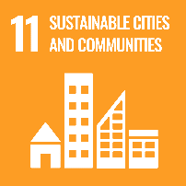  11.2 - 11.6
13 | Member website. Create a “Green” page(s) on the business website where the member’s environmental & sustainability activities and policies can be communicated in advance to all stakeholders. (Where available, this should also clearly direct customers to sustainable travel opportunities to access the organisation) | A.6 | EMS/39 | 12.8 - 12.b
14 | Customer Information. Provide easily accessible information to your guests on the following (where applicable) - Where they can buy locally produced goods - What they can visit locally – Historical, cultural, biodiversity, attractions, activities | A.9 – D.3.1 – D.3.3 – D.3.4 | EMS/40 | 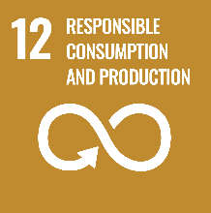  12.8  (13.3, 14.1 15.5- 15.9 - 15.c)

No | WASTE MANAGEMENT | GSTC | Ref | SDGs | YES/NO
15 | Waste Separation. Has implemented a waste separation programme. | D.2.4 | WST/2 | 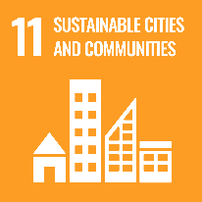  11.6  (12.4, 12.5)
16 | Waste Collection. Only uses waste collectors with valid permits |  | WST/3 | 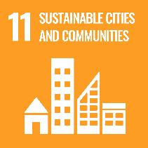  11.6  (12.4, 12.5)
17 | Litter Management. Keeps the public pathways outside the premises free of litter | D.2.6 | WST/29 | 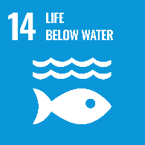  14.1  (6.3, 11.6, 12.4, 2.5)

No | WATER MANAGEMENT | GSTC | Ref | SDGs | YES/NO
18 | Leak Detection. Has an active process in place to identify water leaks. | D.1.4 | WTR/1 | 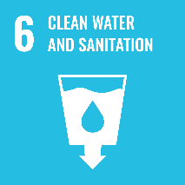  6.4
19 | Flow Measurement. Has measured the flows of water from Showers, Toilets, Urinals, Wash Basins |  | WTR/2 | 6.4
20 | Waste Water Treatment. Is managing a waste water treatment plant to the required standard (where applicable) | D.2.3 – D.2.6 | WTR/3 | 6.4
21 | Grease Trap. Is maintaining a grease trap to collect FOG to the required standard (where applicable) |  | WTR/31 | 6.4

No | ENERGY MANAGEMENT | GSTC | Ref | SDGs | YES/NO
22 | Equipment List. Member has a list of the major energy using equipment within the business which consumes 80% of the energy delivered. |  | E/1 | 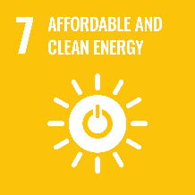
23 | Lighting. Where more than 10% of lighting is not LED, these lights are listed including their type, class, wattage and measured/estimated length of time in use annually |  | E/2

No | GREEN PURCHASING | GSTC | Ref | SDGs | YES/NO
24 | Green Procurement. A Green Purchasing Policy is in place that shows a commitment to responsible purchasing and supporting local suppliers. (Supports Local Suppliers (Goods & Services), Locally produced goods, Green businesses and Responsibly produced goods) | B.3 – B.4 – D.1.1 - D.2.2 | GP/1 | 8.9  (2.3)

Sub-Sector Additional Mandatory Criteria
The following additional mandatory criteria must be implemented if you are one of the following types of business or are a larger operation that includes one/more of these activities within your property.
- Restaurant, Pub, Food Service Operator
- Stand Alone Meetings & Events Centre – PCO’s & DMC’s
- Leisure & Spa facility
- Resort & Golf Club

 | Restaurant/Pub/Food Service Operator | GSTC | Ref | SDGs | YES/NO
25 | Food Provenance. Advises customers of the Country of Origin (Provenance) of all Meats and Poultry and how seafood is Responsibly Sourced - for all menus |  | GP/20 | 2.3 - 2.4  (8.9)
26 | Beverage Provenance. Actively promotes Irish Provenance beverages – including locally produced products, where these are available | B.3 | GP/21 | 2.3 - 2.4  (8.9)

 | Stand Alone Meeting & Events Centre – PCO/DMC’s | GSTC | Ref | SDGs | YES/NO
27 | Programme. Has a formal Green Meeting Programme in place and this is communicated to all potential and current clients – only mandatory where the business is a stand-alone conference/meeting centre or is a PCO/DMC. |  | OTH/ 2 | 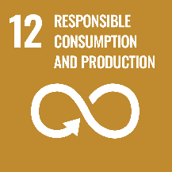  12.8 - 12.b
 | Food Provenance. Advises customers of the Country of Origin (Provenance) of all Meats and Poultry and how your seafood is Responsibly Sourced - for all menus |  | GP/20 | 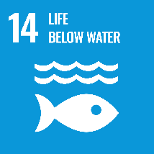  14.4 - 14.7  (2.3 -2.4)
 | Leisure & Spa Facilities
28 | Chemicals. Makes easily available to customers information about the chemical composition and country of origin of Spa Products in use. | D.2.5 | GP/22 | 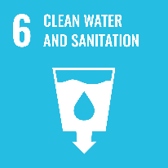  6.3

 | Resorts including Golf Clubs | GSTC | Ref | SDGs | YES/NO
29 | Biodiversity. Where the property has extensive grounds there must be a Biodiversity Plan in place and an easily accessible Biodiversity Map available for visitors use. | D.3.1 | B/5 | 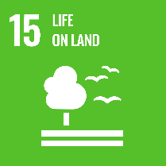  15.1 - 15.5 - 15.9  (6.6, 14.2)
30 | Action Plans. All areas of the Resort/Club must have the GHP Criteria implemented and have action plans for each defined area |  | EMS/9 | 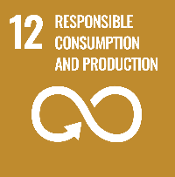  12.b
31 | Golf Clubs. Golf Clubs must have an implementation plan in place to enable the club to achieve the GEO Certified Eco label within a defined timescale. (Or comparable standard - To be agreed with GHP.ie) |  | OTH/4 | 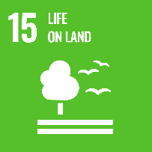  15.1 - 15.5 - 15.9

Silver Award – Mandatory Criteria

EMS/BIODIVERSITY/SOCIAL RESPONSIBILITY/GREEN PURCHASING
No | Mandatory Requirements for Silver Award | GSTC | Ref | SDGs | YES/NO
1 | Continual Improvement: Demonstrate how the business adopts and achieves continual improvement |  | EMS/13
2 | Food Sourcing: At least 4 food products will be produced locally, within 100km radius, and customers advised of this policy | B.3 | GP/4 | 2.3 - 2.4  (8.9)
3 | Chemical Training: Staff shall be trained not to exceed the recommended amount of detergent and disinfectant indicated on the package | D.2.5 | EMS/15
4 | Promotion: Display Green Hospitality Certification certificate in a public area of the business | A.6 | EMS/30
5 | Quality - Environmental Management System documentation is complete and well-presented and achieves a 60% Eco-Label Quality Score and a minimum score of 3 for each criterion |  | EMS/31

No | Mandatory Requirements for Silver Award | GSTC | Ref | SDGs | YES/NO
6 | Data Collation. Collect detailed data on the business’s environmental impacts – waste, water, and energy/CO2 and provide this annually to GHP – using GHP or similar workbooks (Carbon Smart GREENMark members will automatically satisfy this Criteria) | D.1.3 – D.1.4 – D.2.1 – D.2.4 | EMS/5 | 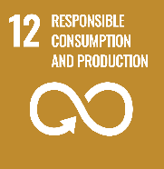  12.6 - 12.b  (13.2)
7 | Chemicals. Record and monitor volumes and costs of all chemicals in use within the business |  | GP/3 | 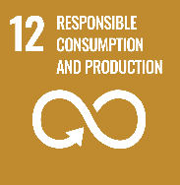  12.4
8 | Suppliers. Encourage suppliers to Go Green by adopting improved environmental practices | D.2.1 | GP/19 | 12.6

WASTE MANAGEMENT
No | Mandatory Requirements for Silver Award | GSTC | Ref | SDGs | YES/NO
9 | Waste Separation by Guests: Adequate provision shall be provided to allow guests to separate waste. Clearly available information in the rooms/other areas shall invite the guests to engage in this process. |  | WST/5 | 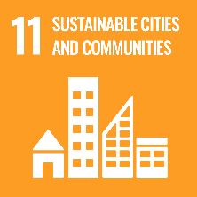  11.6  (12.4, 12.5)
10 | Minimise waste: The business will show what steps it has taken to minimise waste throughout the property, including reducing Single Use Plastics, Single use items, Food Waste & Packaging Waste. (Membership of Plastic Smart GREENMark will satisfy this criterion) | D.2.4 | WST/6 | 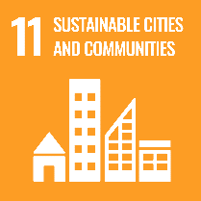  11.6  (12.4,12.5, 14.1)

WATER MANAGEMENT
No | Mandatory Requirements for Silver Award |  |  |  | GSTC | Ref | SDGs | YES/NO
11 | Water saving in bathrooms and toilets. There shall be adequate information to the guest on how to help the business save water |  |  |  | D.1.4 | WTR/4 | 6.4
12 | Watering External plants and gardens. Mains potable water should not be used for this purpose |  |  |  | D.1.4 | WTR/5 | 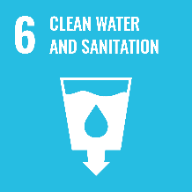  6.4  (15.1)
13 | Urinal flushing. Urinals need to be managed – turned off at night, reduced flows, etc. |  |  |  | D.1.4 | WTR/6 | 6.4

ENERGY MANAGEMENT
No | Mandatory Requirements for Silver Award | GSTC | Ref | SDGs | YES/NO
14 | Air Conditioning maintenance. Any air-conditioning systems with an effective rated output of greater than 12kW requires regular inspection and assessment as specified in the relevant legislation. |  | E/5 | 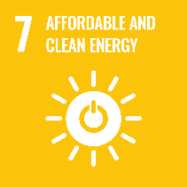
15 | Window Insulation. All windows in rooms shall have an appropriate high degree of thermal insulation. (Excepting where planning restrictions apply) |  | E/6 | 9.4
16 | Control A/C & Heating. If the heating or the air conditioning does not switch off automatically when windows are open, there shall be easily available information reminding the guest to close the window(s) if the heating or the air conditioning is on |  | E/7 | 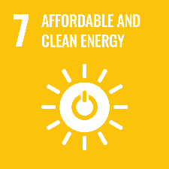  (9.4)
17 | Switching off lights. If there is no automatic off switch (or electronic key card) for lights in the room, there shall be easily available information to the guests asking them to turn off the light when leaving the room. |  | E/8 | (9.4)

 | Mandatory Requirements for Silver Award | GSTC | Ref | SDGs | YES/NO
18 | Light Bulbs. 60% of all light bulbs within the property shall be rated A or B |  | E/9
19 | Equipment Maintenance & Servicing. All main equipment (That uses 80% of the energy) used to provide the business services shall be serviced and maintained in compliance with the law and when otherwise necessary and the work shall be carried out by qualified personnel only. (A detailed list is required) |  | E/10
20 | Boiler Maintenance & Servicing. Maintenance and servicing of boilers should be carried out at least yearly and Management must know the % efficiency of each main hot water or heating boiler in use. (List required) |  | E/11
21 | Hot Water Supply. Member understands and can demonstrate how domestic hot water is produced and distributed throughout the building (A simple schematic will suffice) |  | E/3

Gold Award - Mandatory Criteria

EMS/BIODIVERSITY/SOCIAL RESPONSIBILITY/GREEN PURCHASING.
No | Mandatory Requirements for Gold Award | GSTC | Ref | SDGs | YES/NO
1 | Presentation of EMS. During the verification visit the business will make a formal presentation which will show how the business has integrated the programme into their day-to-day operation and present a sample case study on an environmental improvement they have achieved. (This presentation is recommended for the Silver Award verification visit also) A copy can be saved in this criterions verification folder |  | EMS/12
2 | Promotion: Use Green Hospitality Logos on marketing literature and/or on website with a hot link to www.greenhospitality.ie | A.6 | EMS/14
3 | Food Sourcing: At least 8 food products will be produced locally, within 100km radius, and customers advised of this policy. | B.3 | GP/5 | 2.3 - 2.4  (8.9)
4 | Quality - Environmental Management System documentation is complete, comprehensive, well presented with excellent back-up and detailed benchmarking information - achieving a Quality Score of at least 4 for all criteria and an overall 75% Eco-Label Quality Score |  | EMS/32

No | Mandatory Requirements for Gold Award | GSTC | Ref | SDGs | YES/NO
5 | An Annual Report on the environmental activities of the business has been produced and is available to GHP and all stakeholders. |  | EMS/34 | 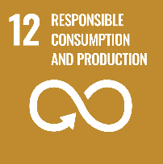  12.6
6 | Biodiversity. Properties that have substantial grounds shall have a biodiversity map and management programme in place. | D.3.1 | B/5 | 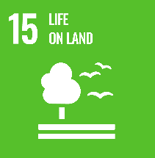  15.1 - 15.5 - 15.9  (6.6, 4.2)
7 | Development: New development adopts sustainable building principles and abides by the NZEB 2020 regulations from 2020 onwards, and any future legislative building regulation. | A.7.3 | EMS/20 | 9.4
8 | Utility Metering: Shall have direct access to the main utility meters (Electricity, Thermal, Water) and shall monitor and record consumption data on a monthly basis. (Recommended: To install sub-metering in high-use areas such as – Swimming Pools, Spas, Laundry, Kitchen, Plant Room, and that all meters are remotely monitored) | A.9 – D.1.3 – D.1.4 – D.3.1 – D.3.3 – D.3.4 | EMS/35 | 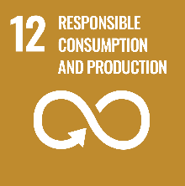  12.b

Waste Management
No | Mandatory Requirements for Gold Award | GSTC | Ref | SDGs | YES/NO
9 | Breakfast – Food Packaging: Property will minimise the use of “one-use” or “single-portion” packaging for food items – with no more than 1 item in use. (Subject to HACCP/Gluten requirements) | D.1.2 | WST/7 | 11.6  (12.4, 12.5)
10 | Disposable Toiletries: None of the following disposable products shall be provided as standard within guest bedrooms: - “one-portion” or “one-use” toiletries or amenities or (For Toiletries) the Hotel is engaged in a dedicated toiletry recycling scheme such as the Clean the World Programme or other. | D.1.2 | WST/8 | 11.6  (12.4, 12.5)

Water Management
No | Mandatory Requirements for Gold Award | GSTC | Ref | SDGs | YES/NO
11 | Urinals are fitted with an automatic (timed), sensor or manual flushing system so that flushing is related to use. |  | WTR/7 | 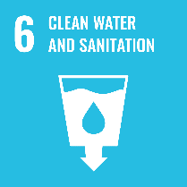  6.4
12 | Water Flows. The average water flow of the taps and shower heads, excluding kitchen and bath taps, shall not exceed 10 Litres per minute | D.1.4 | WTR/9 | 6.4
13 | Towel and Linen Reuse Programme is in place |  | WTR/10 | 6.4

ENERGY MANAGEMENT
No | Mandatory Requirements for Gold Award | GSTC | Ref | SDGs | YES/NO
14 | Energy Management Plan. There will be an energy management plan in place that will have as its primary goal the Minimisation of energy consumption. This should show operating procedures that cover at least 80% of the total energy consumption (Carbon Smart GREENMark members will satisfy this criteria) | D.1.3 | E/17 | (13.2)
15 | Heating/Cooling System. Member understands and can demonstrate how heating/cooling operates and is distributed throughout the building |  | E/4
16 | External heating appliances operate on a zero-carbon output basis | D.2.1 | E/12 | (9.4, 13.2)
17 | Boiler Efficiency. The efficiency of any new boiler (heat generator) purchased within the business’s membership of the Green Hospitality Awards Programme shall be at 4 Stars (92% @ 50⁰C and 95%@70⁰C). |  | E/13 | 9.4

No | Mandatory Requirements for Gold Award | GSTC | Ref | SDGs | YES/NO
18 | Boiler Efficiency. The efficiency of existing boiler(s) (heat generator) shall comply with efficiency standards as laid down by EU Directive 92/42/EEC and/or other regulatory requirements – Boilers with efficiencies lower than 85% shall have a replacement plan. |  | E/14 | 9.4
19 | Leisure Centre - Timers. Timers and controls must be in place to avoid continuous operation of pool water features. |  | E/18
20 | Leisure Centre - Covers. Hot Tubs & Jacuzzis etc. shall have thermal covers and be in use. Where there is no pool cover the business will have a plan to mitigate this which is agreed with GHP. | D.1.3 | E/19
21 | Light Bulbs. 75% of all light bulbs within the property shall be rated A or B |  | E/61
22 | Light Bulbs. 100% of all light bulbs in the business that are situated where they are likely to be turned on for more than 5 hours a day shall have an energy efficiency of Class A or B | D.2.1 | E/21

Platinum Award - Mandatory Criteria

Management
No | Mandatory Requirements for Platinum Award | GSTC | Ref | SDGs | YES/NO
1 | Sustainability Team: This must be of sufficient size to support the sustainability programme, must meet regularly and must be able to show progress against targets set.  All employees must be provided with the opportunity to engage with the Sustainability Team in the development and improvement of the Sustainability Plan and an annual report detailing this engagement, and outcomes, published internally for all employees | A4 | EMS/4.1 | 8.9
2 | Action Plans: Business must have specific Action Plans for each sustainability area – Energy, Carbon, Waste, Water, Biodiversity, Green Procurement, CSR – These should support the targets set. | A3 | EMS/9.1 | 12.b

Management
No | Mandatory Requirements for Platinum Award | GSTC | Ref | SDGs | YES/NO
3 | Monitoring & Metering & GHG's: Members must have online real time consumption monitoring for all Scope 1 & 2 emissions and Water and departmental energy monitoring for large energy using areas – such as Leisure Centers, Kitchens, Commercial laundry’s, including heat, where relevant.  Members must also use the GHP Workbooks (Which utilise the SHA methodologies) to measure their annual GHG emissions - these include Scope 1 & 2 emissions and the following Scope 3 emissions - Business Travel and Transport, Water, Food Waste, and Residual Waste  Members are encouraged to offset residual carbon emissions through the planting of Native Irish Woodlands trees annually and must report on this. | D1.3 - D1.4 | EMS/5.1 | 12.b

Waste Management
No | Mandatory Requirements for Platinum Award | GSTC | Ref | SDGs | YES/NO
4 | Waste Management: Business must track all waste streams using the GHP Waste Tracker and have a comprehensive plan to minimise Landfill, Food Waste and Packaging Waste – KPI’s must be below the national sectoral average. | D2.4 | WST/1 | 11.6  (12.4 - 12.5)
5 | Food Waste: There must be a detailed plan in place to reduce Food Waste, in volume and benchmark, by 50% by 2030 from a 2019 baseline and an ongoing plan post 2030 to continue reductions and the business must have a KPI below the national sectoral average. | D1.2 - D2.4 | WST/11.1 | 12.3
6 | Single Use Plastics: There will be no SUP’s in use in public areas of the business and a detailed plan in place to eliminate all SUP’s in use in Back of House and business has achieved the Plastic Smart GREENMark. | D1.2 | WST/6.1 | 11.6

Water Management
No | Mandatory Requirements for Platinum Award | GSTC | Ref | SDGs | YES/NO
7 | Water Management & Conservation  Members must implement the following:  Carry out a water risk assessment and document it  Where a high risk is identified, context-based water stewardship goals are identified and pursued  Measure all water consumption by type - Mains, Well, Rainwater, other - and include this data in the GHP workbooks  Have an active water efficiency and reduction plan  Confirm that water used is from a sustainable source and does not adversely affect environmental flows  Members must be able to show how they have reduced Mains Water consumption and KPI’s must be below the national sectoral average. | D1.4 | WTR/1.1 | 6.4  (12.2- 12.6, 13.2, 15.1)
8 | Rain/Grey Water: Business must be able to show how they have introduced rainwater and/or grey water harvesting for public toilet use. | D2.3 | WTR/14.1 | 6.4  (12.2, 15.1)

Green Procurement
No | Mandatory Requirements for Platinum Award | GSTC | Ref | SDGs | YES/NO
9 | Circular Economy - Businesses must have a Circular Economy policy that covers every aspect of their business for Goods & Services, including refurbishment and development, with a focus on resource consumption efficiencies, minimisation and reuse.  The Policy must include a commitment to the following; (Where available and of sufficient quality)  To give priority to local suppliers  To support local entrepreneurs in the development of sustainable products and services that are based on the area’s nature, history and culture  To support local entrepreneurs in the sale of sustainable products and services that are based on the area’s nature, history and culture  To strive to minimise the purchase of goods or services from overseas  To actively minimise the purchase of any goods that are air-freighted  To encourage suppliers to adopt a responsible business approach by using cleaner and more resource efficient alternatives across their whole supply chain from product/material sourcing, through manufacture/process and delivery  To only use responsible suppliers for goods & services imported  The Policy must also address internal circular economy opportunities across the whole span of its operations and identify actions that can improve resource efficiency and reduce emissions internally with the following aspects addressed; Energy and water consumption, minimisation of waste and packaging, potential to reuse and recycle materials used and consumed, business and employee travel and transportation, etc. (This is not an exhaustive list)  To document all the above and demonstrate how the business improves from year-to-year | A7.3 - B3 - B4 - D1.1 – D.2.1 - D2.2 – D.2.4 | GP 1.1 | 8.9  (2.3, 12.6- 12.b, 14.4 - 14.7)
10 | Chemical Use: Business must be able to show how they have eliminated the use of toxic chemicals throughout their operation as defined by the World Travel & Tourism Council. | D2.5 | GP/3.1 | 6.3  (3.9)
10a | Chemical Management: All chemicals used within the business must be managed according to the manufacturer’s safety data sheets which includes the safe storage, use, handling and disposal of unused excess chemical and packaging. Members must keep records of annual chemical consumptions. | D2.5 | GP/3.2

 | Carbon Management
No | Mandatory Requirements for Platinum Award | GSTC | Ref | SDGs | YES/NO
11 | Heating/Hot Water: Business must have a plan showing how they will replace existing fossil fuel plant with renewable energy plant to deliver on the 2030 national carbon reduction targets of 51% and how they will achieve 100% Carbon Neutral plant by 2040. | D1.3 - D2.1 | E/24.1 | 13.2
12 | Kitchens/Commercial Laundry: Business must have a plan showing how they will replace existing fossil fuel plant with renewable energy plant to deliver on the 2030 national carbon reduction targets of 51% and how they will achieve 100% Carbon Neutral plant by 2040. | D1.3 - D2.1 | E/24.2 | 13.2

Sustainability and Corporate Social Responsibility
No | Mandatory Requirements for Platinum Award | GSTC | Ref | SDGs | YES/NO
13 | Sustainability Policy: Member has a written sustainability policy addressing environmental, social, cultural, economic, quality, human rights, health, safety, risk and crisis management issues, includes quantifiable targets set for each sustainability area – Energy, Carbon, Waste, Water, Biodiversity, Green Procurement, CSR - and promotes and communicates its commitment through a comprehensive sustainability section on their website.  The policy must show how it is suitable to the business’s size and scope, identify its long-term timeframe and must include details of the members key goals and objectives. | A1 - A3 – D.1.4 | CSR 1 | 8.9  (12.8-12.b, 13.2)
14 | Management System: Member has reviewed and updated its management system so that it fully supports the Sustainability Policy, Goals, Targets and Timeframe. The member must be able to show how the management system is being implemented and all criteria must achieve an 80% Audit Quality Score. | A1 | CSR 2 | 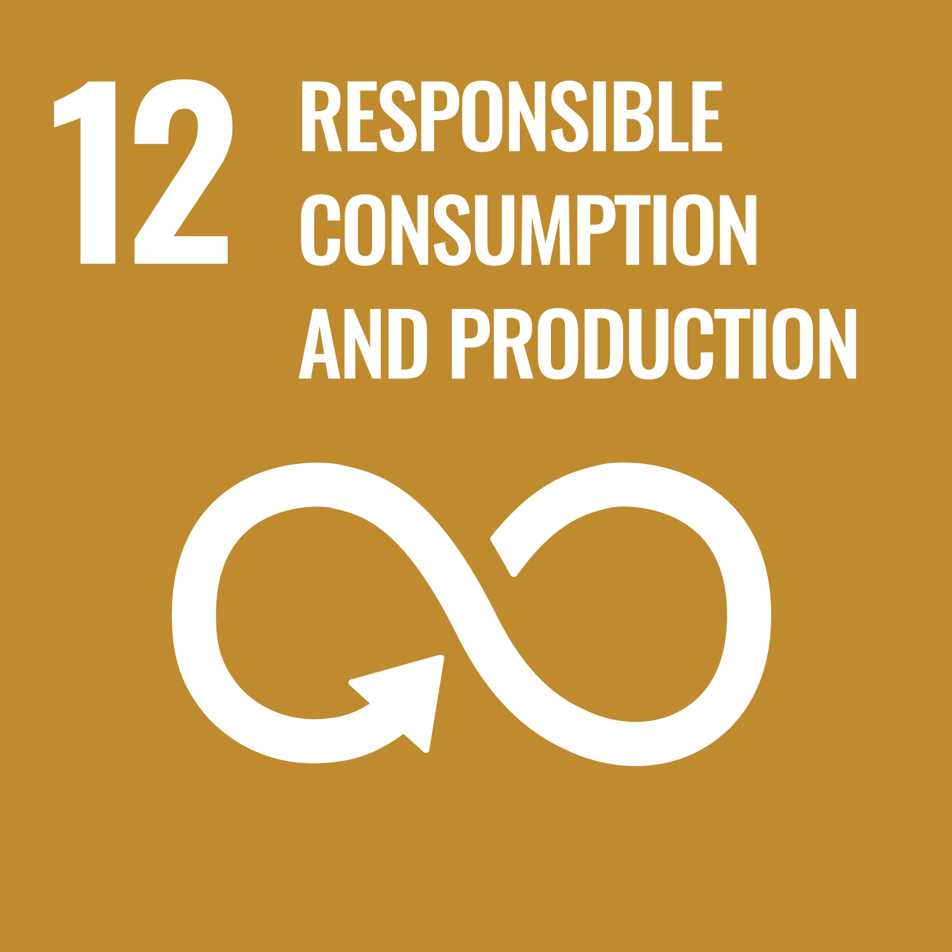  12.6  (13.2)

No | Mandatory Requirements for Platinum Award | GSTC | Ref | SDGs | YES/NO
15 | Regulatory Compliance: Members sign the GHP Sustainability Declaration of Compliance and are compliant with all relevant local, national and international legislation and any Improvement/Compliance notices.  Members are directed to the CSR 3 Guidance Document (which is included as an Appendix) and must be reviewed prior to signing the Declaration of Compliance) | A2 - A7.1-4 - A8 – D.1.4 – D.3.2 – D.3.5 – D.3.6 | CSR 3 | 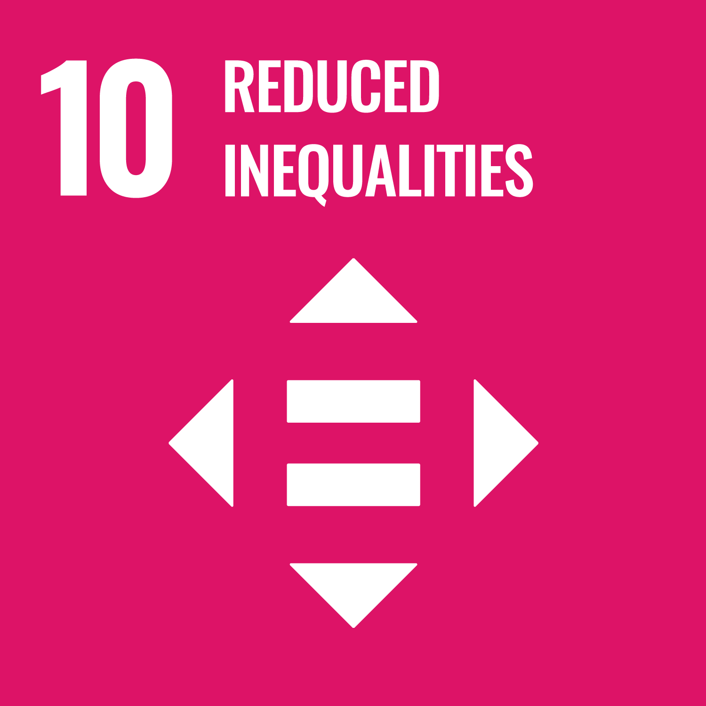  10.3 - 10.4  (15.7, 16.b)
16 | Staff Training: Provide additional training to ensure staff have the required knowledge and skills to implement and maintain the Platinum Criteria, including refresher training annually. (See EMS 7) | A4 | CSR 4 | 8.6  (12.8, 13.3)
17 | Customer Feedback: Member shall measure customer awareness and satisfaction levels of the sustainability performance of the business and document corrective actions taken. | A5 | CSR 5
18 | Accurate Promotion: The member must provide accurate, clear and easily understandable information regarding its sustainable practices and claims. | A6 | CSR 6 | 12.b
19 | Access for all: Where feasible, access should be provided for guests, staff members and other users of the establishment with special needs and be accurately promoted. | A7.4 | CSR 7 | 10.2  (11.7)

No | Mandatory Requirements for Platinum Award | GSTC | Ref | SDGs | YES/NO
20 | Destination Engagement: Members engage with their local community and destination in sustainable tourism planning. | A10 | CSR 8 | 12.8  (6.b, 8.9, 11.a, 17.17)
21 | Community support: Members support local communities and monitor actions taken and contributions made. | B1 | CSR 9 | 8.3 - 8.9  (4.4-4.7, 6.b, 17.17)
22 | Equal Opportunity Employment: Members shall offer employment and promotion opportunities, including in management positions, without discrimination by gender, race, religion, disability or in any other way.  The member must monitor employee diversity and aim to at least match national statistics | B2, B6 | CSR 10 | 8.5  (5.5)

No | Mandatory Requirements for Platinum Award | GSTC | Ref | SDGs | YES/NO
23 | Exploitation and Harassment: The organization has implemented a policy against commercial, sexual or any other form of exploitation or harassment, particularly of children, adolescents, women, minorities and other vulnerable groups. | B5 | CSR 11 | 5.1 - 5.c  (16.2)
24 | Employee Welfare: Members shall pay employees at least the living wage, provide a safe place to work, apply all statutory employee regulations, provide training and development opportunities. | B.1 – B.7 | CSR 12 | 8.8 - 8.9  (1.1, 1.2, 1.3)
25 | Community Protection: The business activities do not adversely impact/affect neighbouring communities as follows:  - Provision of basic food and water services  - Provision of basic energy services  - Provision of basic health & sanitization  - Local access to livelihoods, including land and aquatic resources  - Access to rights-of-way and transport  - Access to local housing welfare. | B.8 – B.9 – C.2 – C.3.2 – D.2.3 – D.2.4 | CSR 13 | 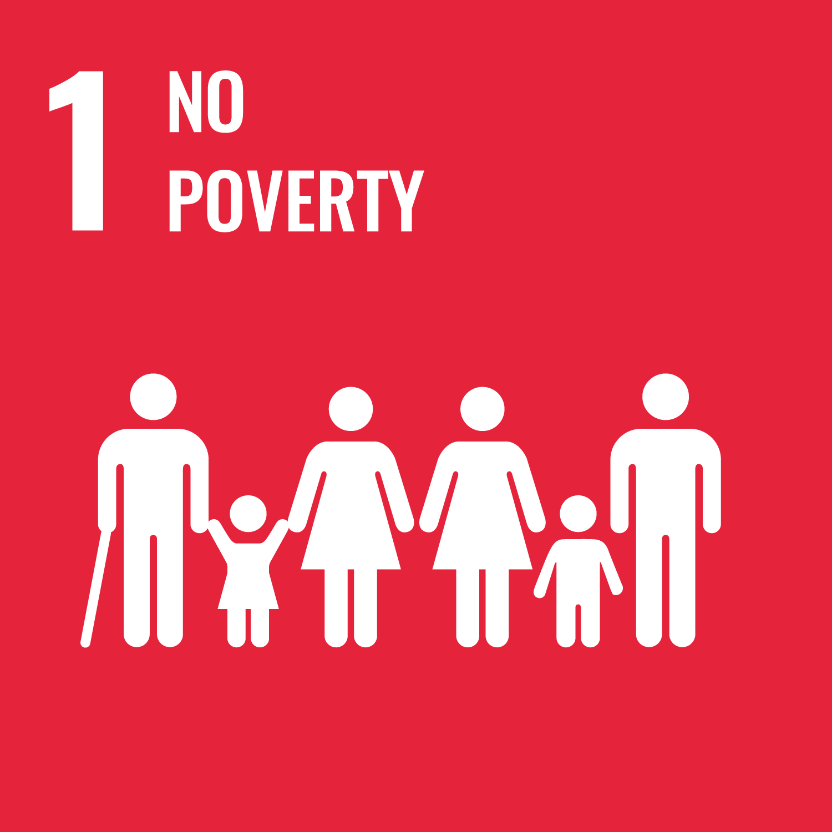  1.4

No | Mandatory Requirements for Platinum Award | GSTC | Ref | SDGs | YES/NO
26 | Protecting, Conserving & Promoting Natural and Cultural Heritage: Members shall implement the following:  The organisation follows international and national good practice and locally agreed guidance for the management and promotion of visits to indigenous communities and culturally or historically sensitive sites in order to minimise adverse impacts and maximise local benefits and visitor fulfillment.  The organisation contributes to the protection, preservation and enhancement of local properties, sites and traditions of historical, archaeological, cultural and spiritual significance and does not impede access to them by local residents.  The organisation values and incorporates authentic elements of traditional and contemporary local culture in its operations, design, decoration, cuisine, or shops, while respecting the intellectual property rights of local communities.  Historical and archaeological artefacts are not sold, traded or displayed, except as permitted by local and international law.  Information is provided to customers about the natural surroundings, local culture, and cultural heritage.  Interpretation of the natural surroundings, local culture, and cultural heritage is provided to customers.  An explanation is given of appropriate behaviour while visiting natural areas, living cultures, and cultural heritage sites. | A.9 – C.1 – C.2 – C.3 – C.4 | CSR 14 | 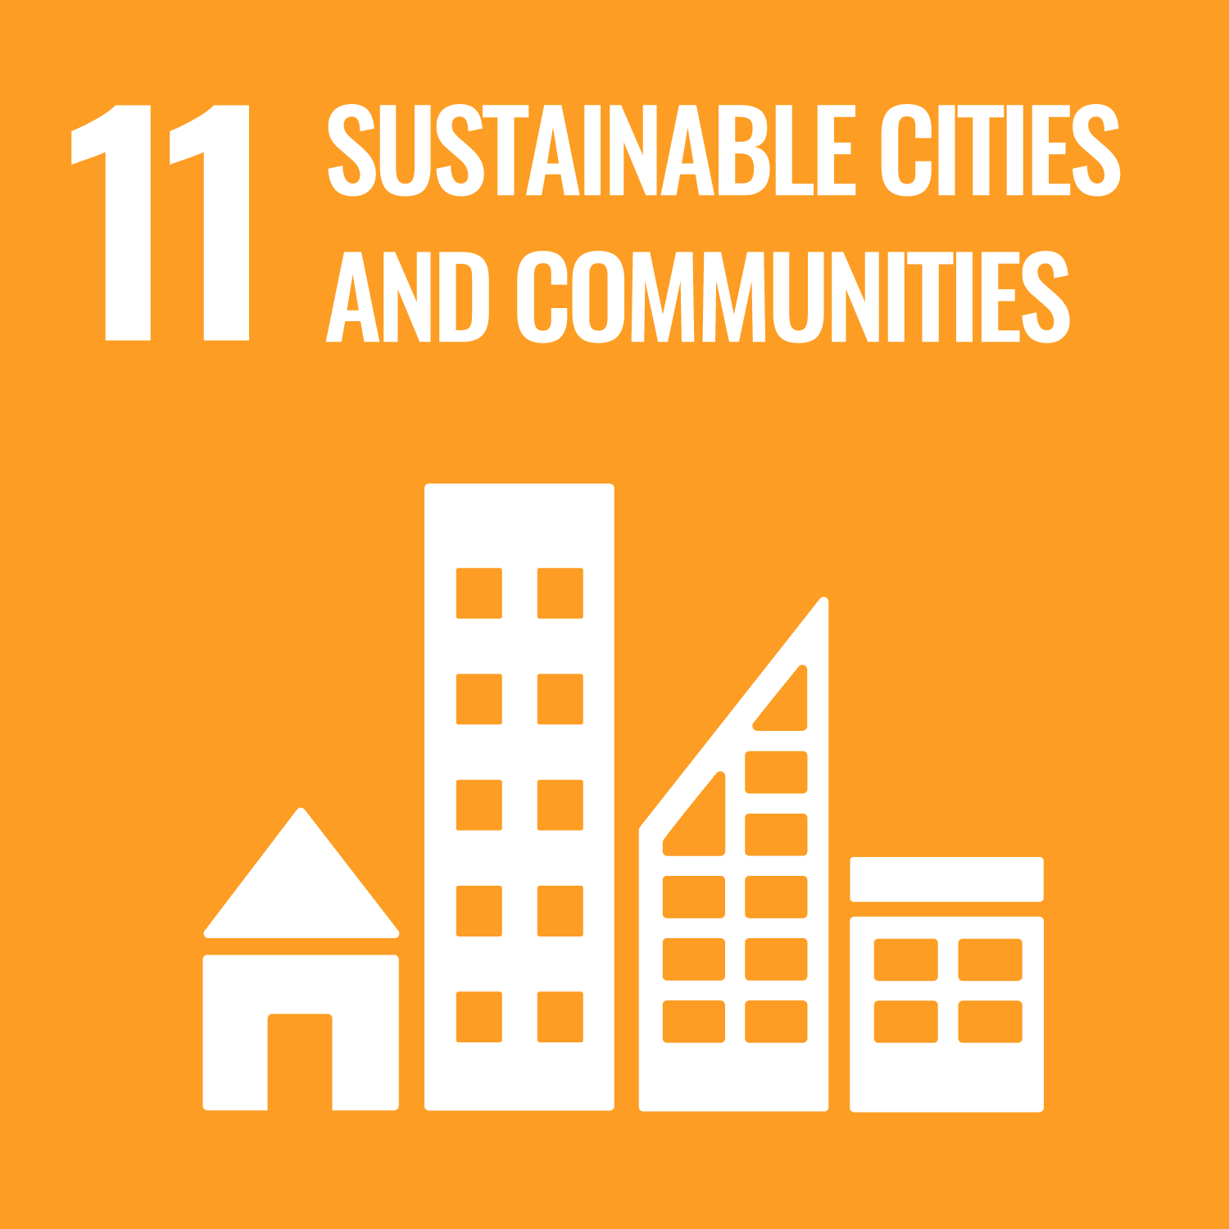  11.4  (8.9, 14.1 -14.5, 15.1 - 15.4, 15.5)
27 | Local Biodiversity Conservation & Protection: This criterion is applicable to both the business premises and local area, and management is required to address each aspect noted, where applicable.  Members are directed to the CSR 15 Local Biodiversity Conservation & Protection Guidance Document (which is included as an Appendix) and must provide sufficient backup documentation to show how the member is in compliance with the requirements within the guidance document. | A.7.1 – A.7.2 - A.9 - D3.1, D3.3, D3.4, D3.6 | CSR 15 | 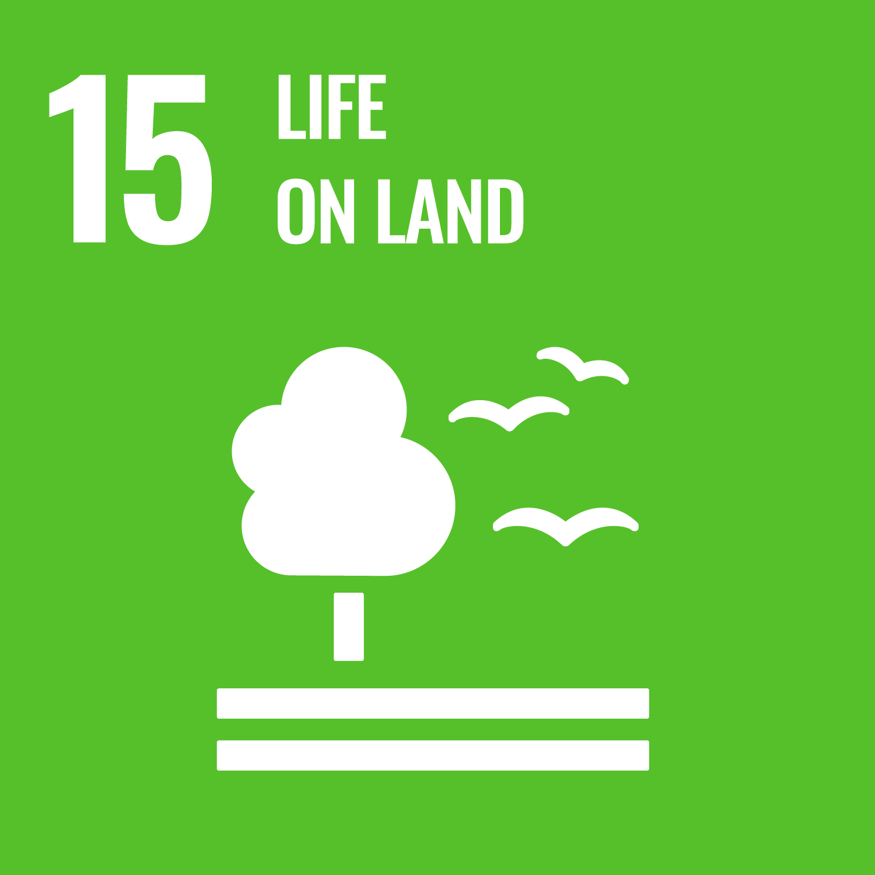  15.1 - 15.5 - 15.7 - 15.8 - 15.9 - 15.c  (2.5, 6.6, 14.1 - 14.2)
28 | Minimise pollution: The organization implements practices to minimize pollution from noise, light, runoff, erosion, ozone-depleting substances, and air, water and soil contaminants. | D.2.6 | CSR 16 | 6.3  (3.9, 14.1)

Additional Criteria

There are 3 ways to achieve additional criteria
- By implementing any of the GHP Optional Criteria noted in the following pages
- By identifying other actions not noted within these criteria that the business is implementing (In-House Optional Criteria).
Other actions can be implemented that relate to any type of criteria - - EMS/ Waste/Water/Energy/Carbon/Biodiversity/Sustainability/CSR, etc.
(Please note that the auditor can disallow optional criteria claimed if it is felt that the actions are of a minor impact, are not being implemented to an acceptable manner or are already covered under another criteria.)
- By implementing any of the Mandatory Criteria that are associated with higher award levels than the one you are aiming to achieve.
For example – if you are going for the Silver Award all the Gold or Platinum Mandatory Criteria are available as “Additional Criteria”

N.B: Please note that sufficient backup is required within the members online additional/optional criteria folders that will allow a 3rd party online audit clearly see what the criteria is, a detailed description, and comprehensive details as to how it has been implemented – it is not sufficient to describe what has been done, you must show what has been done – use photographs, checklists, SOP’s, copies of documentation – etc. along with a description within a verification sheet.

GHP Optional Criteria
No | EMS/BIODIVERSITY/SOCIAL RESPONSIBILITY/GREEN PURCHASING | GSTC | Ref | SDGs | YES/NO
1 | Chemicals. At least 80% of all chemicals, detergents, soaps, toiletries etc. shall be certified environmentally friendly and shall be fully biodegradable. | D.2.5 | EMS/17 | 6.3  (3.9, 12.4)
2 | GREENClean. The business uses GREENClean to replace the majority of cleaning chemicals. |  | EMS / 41 | 6.3  (3.9, 12.4)
3 | Ask environmental questions on guest comment cards |  | EMS/18
4 | Disinfectants: Disinfectants shall be used only where necessary in order to comply with hygiene requirements | D.2.5 | EMS/19

No | EMS/BIODIVERSITY/SOCIAL RESPONSIBILITY/GREEN PURCHASING | GSTC | Ref | SDGs | YES/NO
5 | Provide opportunity for visitors to “Carbon Neutral” their visit |  | EMS/21 | 13.2  (8.9, 11.6)
6 | Business supports a Green Festival Programme in your area | A.10 | EMS/36 | 17.17  (8.9)
7 | Property actively supports Local Sustainability Community initiatives such as Tidy Towns Competition | A.10 | EMS/37 | 17.17  (8.9)

No | EMS/BIODIVERSITY/SOCIAL RESPONSIBILITY/GREEN PURCHASING | GSTC | Ref | SDGs | YES/NO
9 | Business supports Green Destination Programme in your area | A.6 - A.10 | EMS/42 | 17.17  (8.9)
10 | Just Ask Campaign: Premises is a current member of Bord Bia’s ‘Just Ask’ source of food campaign |  | GP/7 | 8.9  (14.4 - 14.7)
11 | Organic Food: The main ingredients of at least two dishes shall have been produced by organic farming methods |  | GP/8 | 2.3 -2.4  (14.4 - 14.7)

No | EMS/BIODIVERSITY/SOCIAL RESPONSIBILITY/GREEN PURCHASING cont.. | GSTC | Ref | SDGs | YES/NO
12 | Responsible Purchasing: The business supports Responsible Purchasing by buying Fairtrade/ Rainforest Alliance tea/coffee, sugar etc. (or similarly internationally affiliated organisation) | B.3 | GP/9 | 2.3 - 2.4  (15.2)
13 | All toiletries in use are certified as “Animal testing free” |  | GP/18
14 | Local School Engagement. Invite local schools to visit your business and support them in their efforts to achieve Green Schools status | B.1 | SR/4 | 4.7
15 | Provide bicycles for customer to use |  | SR/6
16 | Healthy Eating: The Business promotes a Healthy Eating Initiative on its menus |  | SR/7 | 2.1 - 2.2

No | WASTE MANAGEMENT |  |  |  | GSTC | Ref | SDGs | YES/NO
1 | Operate an Onsite Composting System for all waste foods |  |  |  | D.2.4 | WST/11 | 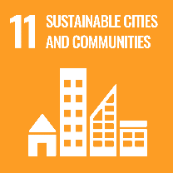  11.6  (12.2 - 12.4 - 12.5)
2 | Minimise the use of bought in bottled water |  |  |  |  | WST/12 | 11.6
3 | Single Use Plastic Bottles. Except where required by law, these shall not be offered in the areas under the ownership and direct management of the business. |  |  |  | D.1.2 | WST/13 | 11.6

No | WASTE MANAGEMENT | GSTC | Ref | SDGs | YES/NO
4 | Donate goods to local charities or re-use centres/companies – linen, old equipment, furniture, office equipment, etc. |  | WST/14 | 11.6
5 | Paper products. At least 50% of toilet/tissue paper/office paper used shall have been awarded the Community eco-label or another national or regional EN ISO Type I eco-labels |  | WST/15 | 11.6
6 | Reused/Refilled Office Products: The business uses reused/refilled printer cartridges and toners for more than 50% of annual consumption |  | WST/16 | 11.6

No | WASTE MANAGEMENT | GSTC | Ref | SDGs | YES/NO
7 | Buy cooking oil in bulk |  | WST/18 | 11.6
8 | Provide a battery collection point for visitors and staff |  | WST/19 | 11.6  (6.3)

No | WATER MANAGEMENT |  |  | GSTC | Ref | SDGs | YES/NO
1 | Rain water is saved and used for non-drinking purposes |  |  | D.2.3 | WTR/14 | 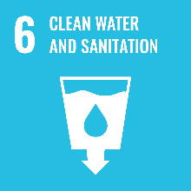  6.4  (12.2, 15.1)
2 | Use of Recycled Water. Water is collected and used for non-sanitary and non-drinking purposes |  |  |  | WTR/15 | 6.4  (12.2, 15.1)
3 | Showers. Water flows shall not exceed 8 Litres per minute. |  |  | D.1.4 | WTR/16 | 6.4

No | WATER MANAGEMENT | GSTC | Ref | SDGs | YES/NO
4 | Toilet Flushing. At least 95% of WCs shall consume 6 litres per flush or less | D.1.4 | WTR/17 | 6.4
5 | Laundry Washing. The commercial washing machines used in the accommodation shall use 12 litres of water or less per kg of wash load |  | WTR/18 | 6.4
6 | Mixer Taps. At least 95% of the taps shall allow a precise and prompt regulation of the water temperature and of the water flow |  | WTR/19 | 6.4

No | WATER MANAGEMENT | GSTC | Ref | SDGs | YES/NO
7 | Shower Timers. Showers in Leisure Centres, staff facilities etc. shall be controlled by push button timer or by infra-red |  | WTR/20 | 6.4
8 | Sub Meter Departmentally. Sub metering shall be extended to all departments within the property |  | WTR/21

No | ENERGY MANAGEMENT |  |  | GSTC | Ref | SDGs | YES/NO
1 | Generation of electricity through Renewable Energy Sources (RES). The business shall have a system that supplies or will supply at least 20% of the overall electricity consumption per year. |  |  | D.1.3 | E/23 | 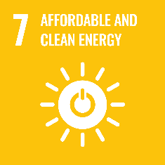
2 | Heating from renewable energy sources (RES). At least 70% of the total energy used for heating/hot water shall come from renewable energy sources. |  |  |  | E/24 | 12.2
3 | Electricity Consumption: At least 80% of the electricity used within the building shall be sourced from a renewable energy source. |  |  | D.1.3 | E/25 | 12.2
4 | Insulation of existing buildings. The building shall have insulation above the minimal national requirements, so as to ensure a significant reduction of energy consumption. |  |  | D.1.3 | E/26 | 9.4

No | ENERGY MANAGEMENT | GSTC | Ref | SDGs | YES/NO
5 | Air Conditioning- A rated. The air conditioning system shall have a Class A+ or A++ energy efficiency rating |  | E/27 | 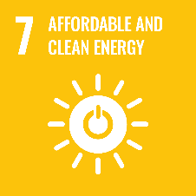
6 | Air Conditioning and Heating - Automatic turn off. There shall be an automatic system that turns off the air conditioning and heating when windows are open |  | E/28
7 | Class A Energy Efficient Equipment: Business chooses Class A Energy efficient refrigerators dishwashers, washing machines and office equipment |  | E/29
8 | Automatic lights off in rooms/bedrooms. Automatic systems which turn the lights off when guests leave their rooms shall be installed in 80% of the guest rooms/bedrooms. |  | E/30
9 | Automatic lights off outdoors. Unnecessary outside lights shall be turned off automatically |  | E/31

No | ENERGY MANAGEMENT | GSTC | Ref | SDGs | YES/NO
10 | Building Management System. The building shall have an Electronic Building Management System which regulates heating/cooling throughout the building. |  | E/32
11 | Weather Compensator. The Heating/Cooling systems shall be linked to an automatic Weather Compensator system to allow for the automatic management for air temperatures. |  | E/33
12 | Heating/Cooling is zoned |  | E/34
13 | Refrigeration Positioning. The refrigerator(s) shall be positioned and regulated according to energy saving principles. This criterion applies to the kitchen refrigerators |  | E/35
14 | Boiler Energy Efficiency. The Heating and Hot Water boilers shall be classified as 4 star (92% @ 50⁰C and 95%@70⁰C). |  | E/36

No | ENERGY MANAGEMENT | GSTC | Ref | SDGs | YES/NO
15 | Combined Heat & Power Plant. The business has installed and uses a Combined Heat & Power system. | D.1.3 | E/37
16 | Heat recovery. The business shall have a heat recovery system for any of the following categories: refrigeration systems, general ventilation/air handling, washing machines, dishwashers, sanitary waste water, etc. | D.1.3 | E/38
17 | Thermoregulation. The temperature in every room can be individually regulated. |  | E/39
18 | Sub Meter Departmentally. Sub metering shall be extended to all departments within the property |  | E/40

No | ENERGY MANAGEMENT | GSTC | Ref | SDGs | YES/NO
19 | Light Sensors/Timers in Back of House areas. The business has installed sensors/timers in all back of house areas to control lighting |  | E/41
20 | Carbon Smart. The business is part of the Carbon Smart GREENMark programme | D.2.1 | E/43 | 13.2

Eco-Labels

The Green Hospitality Eco-label, Silver and Gold Awards are Type 1 Eco-Labels

"Eco-labelling" is a voluntary method of environmental performance certification and labelling that is practiced around the world. An "Eco-label" is a label which identifies overall environmental preference of a product or service within a specific product/service category based on life cycle considerations. In contrast to "green" symbols or claim statements developed by manufacturers and service providers, an Eco-label is awarded by an impartial third-party in relation to certain products or services that are independently determined to meet environmental leadership criteria.
There are many different voluntary (and mandatory) environmental performance labels and declarations. The International Organization for Standardization (ISO) has identified three broad types of voluntary labels, with Eco-labelling fitting under the Type I designation.”
Voluntary Environmental Performance Labelling -- ISO Definitions
Type I -- a voluntary, multiple-criteria based, third party program, that awards a license that authorizes the use of environmental labels on products indicating overall environmental preferability of a product within a particular product category based on life cycle considerations
Type II -- informative environmental self-declaration claims
Type III -- voluntary programs that provide quantified environmental data of a
product, under pre-set categories of parameters set by a qualified third party and based on life cycle assessment, and verified by that or another qualified third party
Further, the ISO has identified that these labels share a common goal, which is:
"...through communication of verifiable and accurate information, that is not misleading, on environmental aspects of products and services, to encourage the demand for and supply of those products and services that cause less stress on the environment, thereby stimulating the potential for market-driven continuous environmental improvement."

Criteria Revisions
GHP updates the GHA criteria over time as part of our continuous improvement process. Recognised practices change, legislation changes, new approaches are identified etc.
GHP Believes that the criteria should adapt at the same time, without removing any key requirements or processes. From 2023 we will record all changes here.

GHA Criteria Version /Date | Updates made
V13.7 – January 2023 | Platinum Award criteria added and compliance with GSTC criteria enhanced
V13.8 – May 2023 | CSR 3 and CSR 15 updated as requested by GSTC

Appendices
There are 2 Appendices enclosed here which members are required to read and implement as they form part of the relevant Mandatory Platinum Award criteria.

15. | Sustainability & Regulatory Compliance | CSR 3
27. | Local Biodiversity Conservation & Protection | CSR 15

15. | Sustainability & Regulatory Compliance | CSR 3

This is to ensure that members operate their business in a manner that is in compliance with all relevant local, national and international legislation and regulations.

This is a voluntary programme, and it is the member’s responsibility to make themselves aware of, and be in compliance with, all current legislation.

We provide members with a Sustainability Declaration of Compliance which all members are required to sign and include within the Online Green Folder.

There are many sustainability regulations concerning activities within businesses, especially in relation to health, safety, labour, environmental, building, planning, water, waste, energy, etc.
Many Certification Criteria explicitly cover the major legal requirements.

Members planning to achieve the Award must make themselves familiar with any specific zoning requirements applicable to their business/property and ensure that they are in accordance with said regulations. Signing the Declaration of Compliance attests to this action

Local Authorities are responsible for enforcing National Sustainability Regulations. When they identify a breach or non-conformance, they will issue a notice to a business requiring compliance. Members are required to declare if they have received any notification relating to any regulation and show how they have become compliant or are in the process of becoming compliant

GHP requires members to be compliant with all Local Authority Sustainability Improvement/Compliance notices.

Relevant practices

Enclosed are a list of relevant practices, many covered by legislation, that the business must assess with respect to their business and only sign the Declaration of Compliance once they have satisfied themselves that their business is compliant.

If unsure of any of the following members should contact their local authority, or the relevant national agency, to clarify the requirements, and the relevant legislation.

- Planning, siting, design, construction, renovation, operation and demolition of buildings and infrastructure comply with zoning requirements and laws related to protected and sensitive areas and to heritage considerations.
CSR 3 Continued……..
The business is aware of, and compliant with, non-statutory area management plans and guidance, for example for particular zones, design, etc.).

- Planning, siting, design, construction, renovation, operation and demolition of buildings and infrastructure take account of, and respects, the capacity and integrity of the natural and cultural surroundings.
- Site selection, design and access have taken account of visual amenity, landscape, cultural and natural heritage.
- Site selection, design and access have taken account of the protection of biologically sensitive areas and the assimilative capacity of ecosystems.
- The integrity of archaeological, cultural heritage, and sacred sites has been preserved.
- The integrity and connectivity of natural sites and protected areas has been preserved.
- Threatened or protected species have not been displaced and the impact on all wildlife habitats has been minimised and mitigated.
- Water courses/catchments/wetlands have not been altered and run-off is reduced where possible and any residue is captured or channeled and filtered.
- Risk factors (including climate change, natural phenomena, and visitor safety) have been assessed and addressed.
- Impact assessment (including cumulative impacts) has been undertaken and documented as appropriate.

- Planning, siting, design, construction, renovation, operation and demolition of buildings and infrastructure use locally appropriate and sustainable practices and materials.
- Local materials, practices and crafts have been used in buildings and design where practicable and appropriate.
- Native and endemic plants obtained from sustainable sources have been used in landscaping and decoration, avoiding exotic and invasive species.
- Plants have been selected for their ability to tolerate prevailing or anticipated conditions e.g. drought tolerant plants
- Sustainable design, materials and construction practices have been used in buildings, with appropriate certification where possible.
- Waste from construction is sorted and disposed of in an environmentally sound manner.

CSR 3 Continued……..

- Planning, siting, design, construction, renovation, operation and demolition of buildings and infrastructure provide access and information for persons with special needs, where appropriate. (See CSR 7)
- Sites, buildings, and activities are accessible to persons with physical disabilities and other special needs, as appropriate to the nature of the operation.
- Clear and accurate information is provided on the level of accessibility.
- Accessibility is certified or checked with relevant experts/user bodies.

- Acquisition by the organisation of land and water rights and of property is legal, complies with local communal and indigenous rights, including their free, prior, and informed consent, and does not require involuntary resettlement.
- Land ownership and tenure rights are documented.
- User and access rights for key resources, including land and water, are documented where applicable.
- There is documentary evidence of communication, consultation, and engagement with local and indigenous communities.
- Evidence of free, prior, and informed consent of local communities is documented, where relevant (showing no involuntary resettlement or land acquisition).

- The organisation takes measures to avoid the introduction of invasive species. Native species are used for landscaping and restoration wherever feasible, particularly in natural landscapes.
- Sites are monitored for the presence of any invasive species.
- Action is taken to ensure invasive species are not introduced or spread.
- A programme is in place to eradicate and control invasive species.
- Landscaping of sites is reviewed to consider the use of native species.

- No species of wild animal is acquired, bred, or held captive, except by authorised and suitably equipped persons and for properly regulated activities in compliance with local and international law. Housing, care, and handling of all wild and domestic animals meets the highest standards of animal welfare.
- The organisation is aware of, and complies with, relevant laws and regulations concerning captive wildlife.
- Existing guidelines for specific tourism activities involving captive wildlife are implemented.
CSR 3 Continued……..
- Personnel responsible for captive wildlife have appropriate qualifications and experience and are fully licensed.
- The organisation is aware of, and complies with, relevant laws and regulations concerning animal welfare.
- There is regular inspection of conditions of captive wildlife and their housing.
- There is regular inspection of the conditions of domestic animals and their housing and handling.

- Wildlife species are not harvested, consumed, displayed, sold, or traded, except as part of a regulated activity that ensures that their utilisation is sustainable, and in compliance with local and international laws.
- The organisation is aware of, and complies with, relevant laws and regulations concerning wildlife harvesting and trade.
- Visitors are informed of regulations concerning wildlife harvesting, consumption, and trade and of the need to avoid buying illegal products/souvenirs derived from threatened species of wildlife notified by IUCN or CITES.
- Where hunting activity is legal, it forms part of a scientifically based, properly managed and strictly enforced approach to conservation.

- Water risk is assessed, water consumption is measured by type, and steps are taken to minimise overall consumption. Water sourcing is sustainable and does not adversely affect environmental flows. In areas of high water risk, context-based water stewardship goals are identified and pursued.
- Water risk has been assessed and documented.
- Where water risk has been assessed as high, water stewardship goals have been determined.
- Water used per tourist/night per source is monitored and managed.
- Equipment and practices are used that minimise water consumption.
- Water originates from a legal and sustainable source which has not previously affected, and is unlikely in future to affect, environmental flows.
- Consideration is given to cumulative impacts of tourism in the locality on water sources.
- Goals for reducing water consumption are in place.
- Staff and guests are given guidance on minimising water use.

CSR 3 Continued……..

Other Relevant Criteria: EMS/2 - CSR 7

Verification Action:

The business shall provide a signed copy of the Declaration of Compliance.

If no notice about Sustainability Improvement/Compliance has been issued: State this on the verification Sheet
If a notice about Sustainability Improvement/Compliance has been issued: Provide a copy of the notice and advise GHP how the business is now compliant – letters from the Local Authority may serve as proof of compliance.

Other Information (Tools, Templates, Guides, Case Studies, etc.)

Sustainability Declaration of Compliance

27. | Local Biodiversity Conservation & Protection | CSR 15

This criterion is applicable to both the business premises and local area, and management is required to address each aspect noted, where applicable. Members must be in compliance with this Local Biodiversity Conservation & Protection Guidance Document and provide documentation to support the guidance.

- Members must document major and notable local biodiversity assets and identify how they can support their protection and preservation.
- The organisation follows appropriate guidelines for the management and promotion of visits to natural sites and interactions with wildlife to minimise adverse impacts and maximise visitor fulfilment.
- Any disturbance of natural ecosystems, on site or locally, is minimised and where identified, rehabilitated and a compensatory contribution is made to conservation management where disturbance of natural ecosystems has taken place.
- The organisation takes measures to avoid the introduction of invasive species.
- Native species are used for landscaping and restoration wherever feasible, particularly in natural landscapes.
- Interactions with free roaming wildlife, taking into account cumulative impacts, are non-invasive and responsibly managed to avoid adverse effects on the animals concerned and on the viability and behaviour of populations in the wild.
- No species of wild animal is acquired, bred or held captive, except by authorised and suitably equipped persons in compliance with local and international law.
- No species of wild animal is acquired, bred or held captive, except for properly regulated activities in compliance with local and international law.
- Housing, care and handling of all wild and domestic animals meets the highest standards of animal welfare.
- Wildlife species are not harvested, consumed, displayed, sold or traded, except as part of a regulated activity that ensures that their utilisation is sustainable, and in compliance with local and international laws.

CSR 15 Continued……..
Information on Local Biodiversity shall be communicated with friendly and explanatory language to customers - ways of doing this can include:
- Flyers/Leaflets at reception
- TV monitors in public areas/guest bedrooms
- Business Apps, QR Codes
- On the “Green” page on the business website
- Setting up a information corner on environmental practices in the lobby
- Pop up on the website explaining the importance of some actions in natural areas which guests are going to visit.

Hotels should engage with and support at least one organisation such as Leave no Trace, which provides education and outreach to protect and enjoy the outdoors responsibly.

The business should actively manage the property organising new initiatives that may include local communities or staff.

Example: install hives across the establishment to preserve honeybees and to contribute to the pollination of surrounding ecosystems.

Member can consult the Additional Resources folder.

The business should be aware of Irish regulations for visiting sensitive sites, wildlife interactions and wildlife viewing.
Members should identify issues, regularly monitor the wellbeing and take measures to minimise disturbance to wildlife, through the help of the most important Irish conservation body, NPWS. The business shall manage interactions with free roaming wildlife so they are non-invasive and avoid adverse effects on the animals concerned.
Member shall ensure to minimise and rehabilitate any disturbance of natural ecosystems and to manage a compensatory contribution to conservation.
Examples:
- decrease hours of visit to sites
- practices to reduce pollution from noise and light, runoff, erosion, ozone-depleting, compounds, and air, water, and soil contaminants

In the matter of hunting, it is recommended to follow the government regulations of National Parks and Wildlife Service (NPWS) since hunting has to be properly managed.

CSR 15 Continued……..

Other Relevant Criteria: None

Verification Action:

The business tells how they have implemented the criteria and adds this Standard to its sustainability policy.

