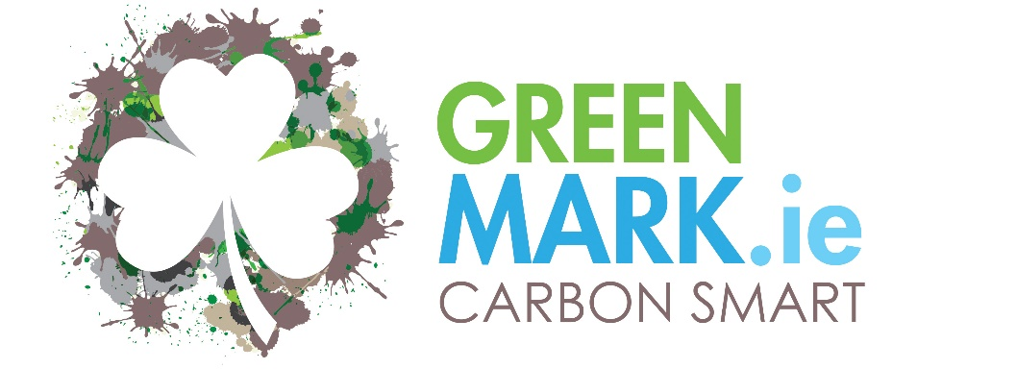
Carbon Reduction Programme
for the Irish Tourism & Hospitality Sector
Objective: To implement a policy to reduce carbon emissions
The programme was created to enable the Irish Tourism & Hospitality support the international requirement for businesses to reduce their carbon emission intensity as one part of the objective to keep Global Warming below 2°C. It is also the gateway programme to achieving the Carbon Neutral12 GREENMark.
Carbon Emissions have been identified as the single greatest cause of Global Warming and every nation, citizen and business enterprise have their part to play. Tourism & Hospitality businesses have their part to play directly, and as part of a global supply chain.
Each business will set a base year, agreed with GREENMark, from which they will measure and report on their performance and develop a Carbon Reduction Plan which will be reviewed and updated annually.
The primary focus will be on Scope 1 & 2 emissions which each business has direct control over. (Industry specific Scope 3 emissions are also included - Business Travel, Laundry management, Landfill & Food Waste, Mains Water) (See over) The Carbon Reduction Plan will also include details as to how the business will reduce other Scope 3 emissions by engaging with suppliers and actively purchasing locally produced goods and services.
As well as being “The right thing to do” engaged businesses will benefit from avoiding increased Carbon Taxes, other expected legislative changes and will secure competitive advantage.

Carbon Emissions Explanation
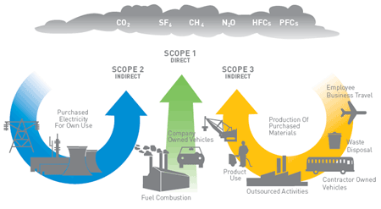
Source: UN Environment – Life Cycle Initiative
A total product carbon footprint is a measure of the direct and indirect greenhouse gas (GHG) emissions associated with all activities in the product’s life cycle. Products are both goods and services. Such a carbon footprint can be calculated by performing (according to international standards) a LCA that concentrates on GHG emissions that have an effect on climate change.
The World Resources Institute (WRI) and the World Business Council for Sustainable Development (WBCSD) have partnered to develop The Greenhouse Gas Protocol: A Corporate Accounting and Reporting Standard. The framework gives business and organizations an internationally accepted methodology to help quantify and report the GHG emissions associated with their operations. Businesses often have multiple objectives in developing such an inventory, but a primary objective is frequently to support the identification of GHG emission reduction opportunities. The accounting framework looks at both direct (Scope 1) and indirect emissions (Scopes 2 and 3), which are explained further below:

Scope 1 – Direct GHG emissions – these occur from sources that are owned or controlled by the company, for example emissions from combustion in owned or controlled boilers, furnaces, vehicles, etc. or emissions from chemical production in owned or controlled process equipment.
Scope 2 – Electricity and heat indirect GHG emissions – this accounts for GHG emissions from the generation of purchased electricity and heat consumed by the company. Purchased electricity is defined as electricity that is purchased or otherwise brought into the organizational boundary of the company. Scope 2 emissions physically occur at the facility where the electricity is generated.
Scope 3 – Other indirect GHG emissions – this is a reporting category that allows for the treatment of all other indirect emissions. Scope 3 emissions are a consequence of the activities of the company, but occur from sources not owned or controlled by the company. Some examples of Scope 3 activities are transport used by customers, the extraction and production of purchased materials, the transportation of purchased fuels and the use of sold goods and services.

Benefits to a Business Adopting a Carbon Reduction Programme
- It shows a commitment to supporting national and global targets to minimise the impact of Climate Change
- It supports the desire of many customers who wish to have a lower environmental impact when travelling
- It supports the aspirations and ideals of multiple generations of employees, present and future, to work for a responsible company
- It assists the business in reducing costs by using less energy and helps avoid the impact of increasing energy taxes
- It enables a business to promote their product/service to like-minded companies who are also working to minimise their carbon emissions – delivering competitive advantage.
There are many hotel and hospitality businesses around the world that are already setting targets and implementing low Carbon Policies - Hilton, NH Hotel, Melia, Premier Inn, Radisson Blu, Hyatt etc.
This programme enables individual hotels adopt similar policies and gives access to a body of knowledge and support that can help them achieve their goals.
We will have 2 levels of Carbon Smart GREENMark;
- Member – started the programme
- Achieved – to recognise those who have implemented and achieved their targets

Who can Apply? - This programme is open to any Tourism and Hospitality Business in Ireland. There are discounts available for businesses that are members of the Green Hospitality Programme.

Key parts to this programme;
The Carbon Smart Pledge – Businesses sign up to the programme and commit to implementing it over a defined period – A rolling 5-year commitment.
Benchmarking. The business must benchmark their carbon emissions (Scope 1 & 2 and selected Scope 3). The methodology used will be the HCMI (Hotel Carbon Measurement Initiative) The business must also adopt KPI’s that will be used to measure their performance over time. The GREENMark will work with the business to identify the relevant KPI’s that will be reported on.
Carbon Emissions Certificate – GREENMark will issue the business with their base year Carbon Emissions certificate (and intervening years if applicable) following receipt of benchmark data.
Target Setting – Each business must set a 5-year target that is at least in alignment with current national goals. Each business should initially set a general 5% annual reduction in carbon emissions/intensity from their base year. The business target must be agreed with GREENMark and must also reflect changing requirements set by national governments. (GREENMark recognises that major carbon reduction actions will occur at times following large project implementation and as such the overall 5-year targets and associated action plans are more relevant that annual reductions)
Members are encouraged to exceed the base targets where possible
Carbon Reduction Plan – Each business must have a Carbon Reduction Plan which identifies what actions the business will implement to achieve this reduction. These could be a series of smaller initiatives or a couple of very large initiatives. These actions should stretch out for the 5-year rolling period

Documentation – Each business must store all energy consumption records, benchmark data, plans and annual reports in their Carbon Smart GREENMark Online folder to enable GREENMark to review them.
Annual Reporting - Each year the business must produce a Carbon Reduction report and review and update their 5-year plan and targets. Any changes must be identified and explained.
Annual reports and key documents must be published online in the businesses website to enable stakeholders review them and is a clear statement of transparency and openness.
Stakeholders should be invited to comment and make suggestions to the business as to how they could implement other actions to support their carbon reduction commitments.
Continuing the work – Having implemented the carbon reduction programme within their business each member will support GREENMark in encouraging suppliers to also benchmark and calculate their product/ service carbon footprint which would allow selected Scope 3 emissions to be calculated.
General – It is not sufficient for a business to reduce carbon emissions solely by buying renewable energy. The business must take specific internal actions to reduce the use of energy, where financially feasible. A business that falls above its sectoral energy consumption average will need to clearly identify why this is the case and the reasons the business cannot reduce its consumption.
Terms & Conditions - Financially feasible arguments will be reviewed by the GREENMark and the GREENMark reserves the absolute right to refuse to accept the arguments. Members must pay their annual fees within 30 days of invoicing. By joining the Carbon Smart GREENMark programme businesses accept these conditions and all the other conditions and future conditions that will be published over time. Failure to abide by the terms & conditions will result in the GREENMark being withdrawn with no refund of any fees paid. GREENMark reserves the right to refuse entry to the programme to any business, without prejudice.
Costs
Initial Programme setup - Benchmarking, KPI’s, Carbon Certificate, Target setting, Audit
€2,000 per property
€1,500 per property for GHP Members
Annual Membership
Following the awarding of the GREENMark annual fees as follows will be payable;
€2,500 per property to include an annual review
€1,750 per property for GHP Members (Member, Eco-label, Silver, Gold Award Certified) - to include an annual review, GHP Annual Membership fee and Carbon Neutral12 GREENMark when achieved
€2,500 per property for Platinum Award GHP Members - to include an annual review, GHP Annual Membership fee and Carbon Neutral12 GREENMark when achieved
Fees as of 01/01/2024 – subject to review

Programme Administration
The Carbon Smart GREENMark will be administered by GreenHospitality.ie.
Membership will be managed online and all members are required to abide by the conditions and standards.
Promotion
All Carbon Smart GREENMark businesses will be listed in the Carbon Smart GREENMark register in the GreenTravel.ie website. Where Carbon Smart members are also listed as Responsible Businesses, they will be identified on the GreenTravel.ie map and a Carbon Smart GREENMark logo put on their listing page.
Each Carbon Smart business will receive a Window Sticker and copy of the Carbon Smart Logo to promote their commitment and achievement.

Other Resources
Supplier Listing
Green Hospitality will work with members and others to identify suppliers who can provide alternative products or services that will assist members in achieving the Carbon Smart standard.
Information on these will be found in the GreenTravel.ie website or in the GreenHospitality.ie Green Supplier website.

Other Resources – where available these will be identified through the GreenHospitality.ie website

APPLICATION FORM
We wish to become a member of the Carbon Smart GREENMark programme.

Company Name

Type of Business
Is your business already a GreenHospitality.ie member and are your fees up-to-date?

Address

Email
Telephone

Contact Name

Position
Personal Email address

Signature  Date | ________________________________________________

Please complete this form and send it to GreenHospitality.ie, Eastgate Village, Little Island, Cork. T45A363 or email it to info@greenhospitality.ie

