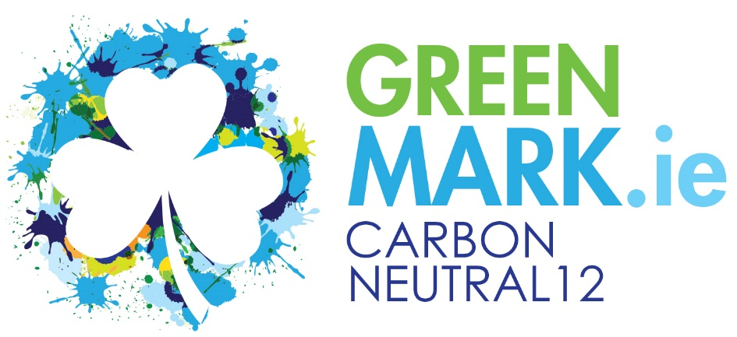
Carbon Neutral
Carbon Neutral, also called carbon neutrality, is a term used to describe the actions of organisations, businesses and individuals taking action to remove as much carbon dioxide from the atmosphere as each put in to it. The overall goal of carbon neutrality is to achieve a zero-carbon footprint.
A Carbon Neutral hospitality business is generally accepted as a business that has measured its Scope 1 & 2 Emissions (Fossil Fuels consumed on-site and Electricity purchased) and industry specific Scope 3 Emissions (Business Travel, Laundry impacts, Waste and Water emissions), engaged with key suppliers to identify low-carbon suppliers and encourage others to reduce their total emissions (Other Scope 3 for the business), and achieved a zero-carbon footprint by implementing a Carbon Reduction Programme, reducing energy consumption, investing in renewables and offsetting their net carbon footprint, if necessary.
The GREENMark recognises that many businesses are interested in achieving this status and has created the Carbon Neutral12 GREENMark as a standard to enable businesses to achieve this and promote their actions to consumers.

Carbon Neutral12 GREENMark
The Carbon Neutral12 GREENMark can only be awarded to a business that has first achieved the Carbon Smart GREENMark and has demonstrated a sustained approach to energy efficiency within their property.

Achieving Carbon Neutral12 status is not possible by simply buying green energy and/or offsetting carbon footprints. Businesses must have an ongoing carbon/energy reduction plan and must be able to show how they have reduced their energy/carbon intensity/consumption over a sustained period – to be agreed with the GREENMark.
A Carbon/Energy Management plan must also be in place showing what steps the organisation is taking to continue reducing their energy intensity – which leads to a lower carbon footprint.
Scope 3 Emissions
The vast majority of tourism & hospitality businesses will be regarded as SME’s. Under current reporting rules on carbon, SME’s are exempt from measuring Scope 3 emissions as it is seen as being too burdensome, expensive and outside of SME’s expertise levels. The GREENMark includes a few industry controllable ones to enable the business to truly measure its controllable emissions.
It is not the intention of the GREENMark at this time to create a model where the carbon footprint of all goods and services (Scope 3) need to be calculated as the medium-term objective is for each supplier to achieve carbon neutrality which would therefore render goods and services supplied as carbon neutral.
However, the Carbon Neutral12 GREENMark businesses must include in their Purchasing Policy a stated preference for suppliers to have achieved Scope 1 & 2 carbon neutrality. They must give this a weighting that would be advantageous for the supplier as part of their competitive quote.
The purchasing policy must also prefer locally supplied goods (Of Irish Provenance) and services and actively source these which will result in reduced travel miles. (All suppliers delivering more than 1% of the total value of all purchased goods must be engaged with to encourage them to adopt a low carbon strategy)
The business must be able to show what % of goods/services used are produced locally – within 100km, or less.

Green Electricity
The GREENMark accepts the principle of Green Electricity as approved by SEAI and strongly suggests that the economic route to decarbonise a business’s electricity supply is to buy 100% Green Electricity from an Irish Supplier. Members must provide documentation each year to confirm that they are buying 100% renewable electricity.
Green Fossil Fuels - Gas
Biomethane or Biogas is increasing in its availability and the GREENMark accepts 100% biomethane supplies – members must be able to produce certificates to back up these each year.
Where a % of the “Green Gas” is provided using carbon offsets the member must be able to produce certificates and documentation showing where in Ireland these offsets are taking place, and that they are from Native Irish Woodland Plantations.
Heating Oil/Kerosene
A member using oil for the majority of their heating/hot water production must be able to show in the Carbon Reduction Plan how they will eliminate this fuel by 2030 and 100% of its carbon emissions must be offset on the Island of Ireland.
Where oil use is a smaller % the member must be able to show how this will be reduced by 50% by 2030 and 100% by 2040 and 100% of its carbon emissions must be offset on the Island of Ireland.
HVO – Hydrotreated Vegetable Oil – HVO – can be used instead of fossil fuel oil as long as the source can be shown, and certified, to be from a sustainable source and specifically excludes any HVO that is derived from Palm Oil. HVO delivers a 90% reduction in carbon emissions.
(Members who use Oil must agree with the GREENMark in advance their plans before the GREENMark can be awarded).

Carbon Offsets
We follow the PAS 2060 methodology when carbon offsetting is required. We also require primary offsetting to take place in the region where the business emits the carbon emissions – therefore for Irish Members it must be on the Island of Ireland.
Offsetting must be through the planting of additional Native Irish Woodland trees, not on bogs or peatland, and members must be able to provide sufficient documentation to identify exactly where this took place and show how this planting achieved the principles of additionality and permanence.
We recognise carbon offsetting tonnage from the Green Trading Company Carbon Offset Bank. If members use other companies or plant trees themselves an annual additional certification fee will be applied – this will be Estimated on a case-by-case basis. (GREENMark members will be required to lodge their offset certificates with the GREENMark Carbon offset Bank and the GREENMark will retire them annually and issue relevant certificates.
All Carbon Offsets claimed must be approved, in advance, by the GREENMark, and the GREENMark reserves the absolute right to refuse to accept the offset request. (This forms part of the Terms & Conditions of joining the programme)

Achieving the Carbon Neutral12 GREENMark
The following conditions must be met;
Must have achieved the Carbon Smart GREENMark.
Must have a Carbon Reduction Plan which must include the following;
- Identify and quantify energy efficiency actions taken and how they will be maintained
- A list of planned energy efficient actions that will reduce total energy consumption – with quantification
- Annual Benchmarking and KPI analysis provided – using the GHP Workbooks and Services
- Must include the Carbon Emissions from the businesses corporate travel (Including vehicles), any external laundry operation and Landfill and Food Waste emissions
Where the business is applying Carbon Offsetting or purchasing renewable energy full details of these must be provided, as noted in this guide.
Must publish on their website complete details of their Carbon Reduction Plan – identifying projects undertaken, energy efficiency achievements and how they are achieving carbon neutrality.
Must include within their Purchasing Policy a commitment to
- Prefer suppliers that are also engaged in Carbon Reduction programmes – focusing on Scope 1&2 emissions
- Prefer suppliers that operate their business in an environmentally responsible manner
- A process and timescale to engage with any supplier that delivers more than 1% of the total value of all goods delivered – to identify their low carbon strategy
Must provide GREENMark with the required information annually to maintain their Carbon Neutral12 status.
Must accept the terms and conditions

Carbon Neutral12 GREENMark
Programme Costs
Programme setup
- Review of Carbon Reduction Plan
- Review of Carbon Footprint claims
- Verification of renewable energy, carbon offsets, etc.
- Review of updated Green Purchasing Policy showing how suppliers with low carbon footprints are preferred
- Website review to confirm detailed information is provided for stakeholders
€2,000 per property – This is a one-off payment, subject to the member maintaining their Carbon Smart GREENMark membership and actions on an annual basis.
Annual Membership
Included within your Carbon Smart GREENMark membership which must be reported on annually.

APPLICATION FORM
We wish to become a member of the Carbon Neutral12 GREENMark programme.
Company Name

Type of Business
Is your business already a GreenHospitality.ie member and are your fees up-to-date?

PO Number
Address

Email
Telephone

Contact Name

Position
Personal Email address

Signature  Date | __________________________________________________

Please complete this form and send it to GreenHospitality.ie, Eastgate Village, Little Island, Cork. T45A363 or email it to info@greenhospitality.ie

