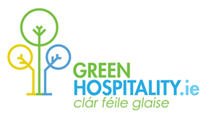
Green Hospitality Award

Environmental & Sustainability Certification & Resource Efficiency Programme for the Irish Tourism & Hospitality Sector

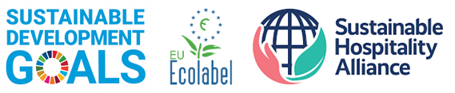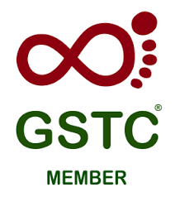

Aligned with the UN Sustainable Development Goals, Global Sustainable Tourism Council, EU Ecolabel and the Sustainability Hospitality Alliance Hotel Carbon, Water & Waste Measurement Methodologies

www.greenhospitality.ie
Valid to 01/01/2025

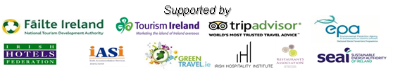
Green Hospitality – Awards and Services

Green Hospitality (GHP) is the Irish Hospitality, Travel & Tourism Resource for Sustainable and Responsible Tourism. GHP’s objective is to support the Irish Hospitality sectors drive to improve its Environmental & Sustainability performance by providing certification, promotion, resource efficiency & consulting services.

CERTIFICATION
Green Hospitality Award – Eco-label, Silver, Gold. Our internationally recognised Third-party Environmental Sustainability Certification Awards Programme. It is aligned with the UN Sustainable Development Goals (SDGs), Global Sustainable Tourism Council (GSTC) criteria, EU Ecolabel and the Sustainability Hospitality Alliance Hotel Carbon, Water & Waste Measurement Methodologies.
Green Hospitality Award – Platinum. Our GSTC Recognised Third-party Environmental & Sustainability Certification Award. For those businesses that wish to implement a full sustainability programme.

MICRO-CERTIFICATION
GREENMark Eco-friendly Business. Aimed at Micro and SME’s mall businesses, we provide a simpler approach that enables them to be recognised for their environmental actions – micro-certification. This can also be a good base for larger businesses to prepare for full certification.

PROMOTION
GreenTravel.ie - Our consumer website promotes environmentally sustainable tourism businesses to visitors and tourists. A listing on this website is open to all tourism/hospitality businesses that have achieved any environmental or sustainability certification or recognition or label that is recognised by GHP.

CONSULTING – Certification Support, Resource Efficiency, Benchmarking, Carbon Footprint, Training, Cost Saving
Green Trading Company. GTC offers a range of services that can operate on their own or to support and complement the Green Hospitality Awards or GREENMark programmes.
Our core services include - Certification Support Programme, Benchmarking & KPI analysis, Carbon Footprinting, Resource Efficiency Health Check (Energy, Water, Waste), Micro-certification, Employee training, on-site environmental consulting, etc. – with a consistent focus on cost saving.

Go online to view any of these services and use the relevant contact forms if you are interested in engaging with any of these services.
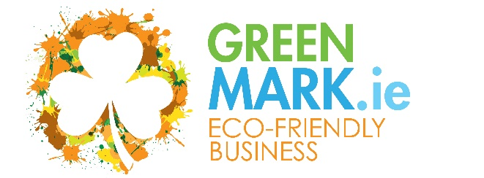  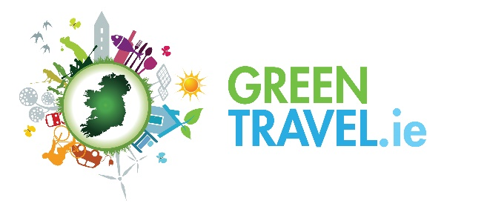 | MICRO-CERTIFICATION  The Eco-friendly Business GREENMark is our micro-certification programme to enable smaller hospitality businesses, attractions, activities, etc. secure recognition for their sustainable activities  PROMOTION  GreenTravel.ie is Irelands Sustainable Hospitality website where we bring together all sustainable businesses across Ireland – either certified or recognised for their sustainable activities.  It is free for GHP Certified or GREENMark Eco-Friendly businesses. www.greentravel.ie
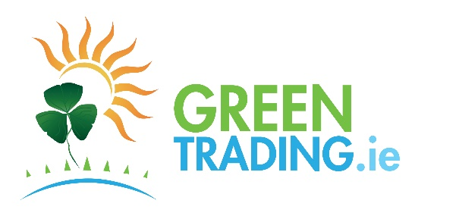 | RESOURCE EFFICIENCY, CONSULTING, TRAINING  The Green Trading Company provides Resource Efficiency (Energy, Water, Waste), Consulting, Training, and several other services to businesses. The focus is on cost savings.  Services include: GREENClean, GREENFootprint, GREENEnergy, GREENWater, GREENWaste.
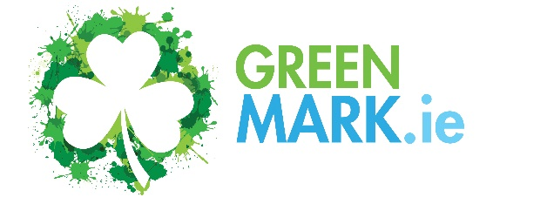 | Micro Certification – For businesses that wish to achieve additional recognition, or to focus on specific actions – Plastic Smart, Energy/Carbon Smart, Carbon Neutral12, Water Smart, Waste Smart. Can operate standalone or build towards certification.

Green Hospitality Award Programme - Certification
Eco-label, Silver, Gold & Platinum

Our internationally recognised Third-party Environmental & Sustainability Certification Programme. It is aligned with the UN Sustainable Development Goals (SDGs), Global Sustainable Tourism Council (GSTC) criteria, EU Ecolabel and the Sustainability Hospitality Alliance Hotel Carbon, Water & Waste Measurement Methodologies and focuses on the implementation of an Environmental Management System with detailed performance and actions relating to Energy, Water & Waste Management followed by social & economic sustainability pillars.

The Programme is designed as a Step-by-Step approach allowing businesses implement the required criteria at their own pace and initially embed environmental sustainability as part of their business model whilst they build towards the full sustainability award.

The Eco-label Award is the first step. The Silver and Gold Awards build on the Eco-label criteria whilst supporting additional sustainability and savings initiatives within the business and the Platinum Award (GSTC Recognised) incorporates Corporate Social Responsibility, sustainability, and deeper environmental actions

GHP Membership - Getting Started

New members commence on our GREENSave Initial Membership Package which focuses on achieving the Eco-label Award. This service is valid for up to one year and includes access to the documentation and training required to achieve the Eco-label Award, and an Eco-label Award audit.
Once the Eco-label Award is achieved the now Certified member commences their formal certified membership and have access to the wider Awards documents and supports.
Should you wish additional support our sister organisation – Green Trading Company (GTC) – provides services designed to enable your business achieve certification quickly, or other sustainability actions.

Certified Membership Key Benefits.

- 3rd Party Environmental/Sustainability certification
- Benchmark & KPI Workbook - use of our Benchmarking Tool using International Standard methodologies
- Access to all GHP Tools, Templates, Checklists, etc.
- Use of the GHP Logos allowing for national/international promotion
- Free Entry to GreenTravel.ie – the GHP online travel & tourism website
- Access to the GHP Resource Database and good practice updates
- Discounted or Free access to GHP training, workshops, conferences, etc.

Membership Fees and Packages

 | GREENSave  Initial Membership | GREENSave – Annual Membership Fees
 |  | Standard | Support Package | Enhanced Package
Utility Costs | Standard/Enhanced  (from) | (Published Programme resources only - no direct support) | (Standard Membership plus Online Support) | (Support Package plus Annual Site Visit)
Under € 75,000 | €895/€1,500 | €595 | €795 | On Demand
Under €150,000 | €895/€1,500 | €595 | €795 | On Demand
Under €300,000 | €895/€1,500 | €795 | €895 | On Demand
Over €300,000 | €895/€1,500 | €795 | €895 | On Demand

VAT @ current rate will be charged. Payment conditions apply. All New members commence with a GREENSave Initial Membership Package.
Utility Costs – Total Annual Costs of Energy, Water (Supply/Disposal) plus Waste Costs (Net of VAT)
Certification – A Desk Audit is required for any business to achieve any certification level followed by a Site Visit to verify compliance for Silver, Gold and Platinum Awards. An initial Desk Audit for Eco-label is included in the GREENSave Initial Membership
Desk Audits - Eco-label/Silver/Gold Award - €500 Platinum Award - €1,000
Verification Site Visits - Silver/Gold Award - €750 – Platinum Award - €1,000
Travel & Subsistence costs to conduct Verification Visits will be charged at cost – this will be agreed with member in advance-
Specific Conditions: Maintaining certification to any of the GHP award standards requires on-going verification through our online Green Folder and either an annual site visit or a formal on-site audit at least once every three years.

Certified members are required to commit to a minimum of three years membership and Awards are only valid for businesses that are current fully paid-up programme members.

Certification audits will be charged for, unless included within a membership package. Members pay an annual fee based on their Utility Costs.

Additional Conditions
All GREENSave packages require a minimum 3-year membership commitment.
All members must give 6 months’ notice of membership cancellation prior to the current membership package end date – membership packages automatically renew unless cancelled.
All members are automatically bound by the Green Hospitality Programme general terms and conditions which are found in the GHP website on payment of their initial membership fee.
It is required that accommodation providers on any GREENSave package will also provide overnight accommodation and subsistence for each site visit to enable a thorough property assessment. Where travel exceeds 100km from Cork the member will be responsible for all travel and time related costs – to be agreed in advance.

GREENSave Membership Packages
Initial Membership
Standard: Access to Eco-Label resources for up to 1 year - Onboarding to the Eco-Label Award Programme, GHP Environmental Tracker Workbook, Online Green Folder, Online GHP Training and Workshops and a Desk Audit to achieve the Eco-label Award
Enhanced: Standard package plus a Site Visit to support Green Leader and identify opportunities.
Once a business achieves certification it is required to pay its first year’s certification fees
Certified Membership - Annual - Standard
Includes: Annual Membership, GHP Benchmark Workbook, Online Green Folder, Online GHP Training and Workshops. Access to members section of GH website. Member Discounts on specified GHP sustainability programmes.
Use of GH Award Logos, Certificate, Listing in GreenTravel.ie, Ability to list as a Green/Sustainable business in third-party websites. Desk Audits, Verification Site Visits and Advice/Support are additional costs
Certified Membership - Annual – Support Package
Includes: Certified Membership Annual Standard features
Online resource efficiency support (Energy, water, raw materials, waste), subject to limits.
An annual Desk Audit for Eco-Label, Silver and Gold Awards is included, if required – Verification Site Visit is an additional cost. (Platinum Award Desk Audits are charged additionally)
Certified Membership – Annual - Enhanced Package
Includes: Certified Membership Annual Support Package
The enhanced package will be agreed with the member and may include one/more site visits and may be a multi-annual service to include on site and online support, audits, and verification.

(Additional site visits can be delivered – if required, please discuss with GHP)

Application/Expression of Interest (Cross one Out)

Company Name

Type of Business
Address

Annual Cost of Utilities – (Energy, Waste & Water) | €
Package Required  Circle/Mark/Identify the package / programmes you are interested in. | GREENSave – GHP Certification Membership  - Initial Membership  - Standard  - Enhanced  - Standard Membership  - Support Package Membership  - Enhanced Package Membership  Other (Specify):
PO Number:
Telephone
Your Name
Your Position
Your Email Address
Signature

Date

Please complete this form and send it to GreenHospitality.ie, Eastgate Village, Little Island, Cork. T45 A363 or email it to info@greenhospitality.ie

