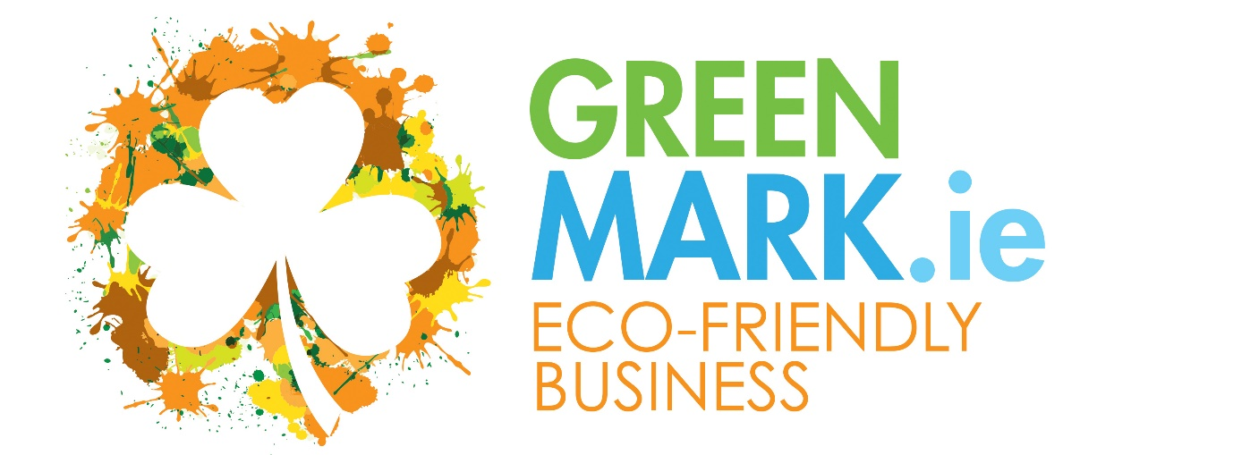

An Environmental Micro-Certification Programme for Smaller Businesses

Information and Application Form

Eco-Friendly Business GREENMark
Small Business Sustainability - Micro-Certification Eco-Label

Most small businesses operate in a responsible and sustainable manner but are not formally certified or a member of a recognised sustainability programme. Irish tourism businesses on the Island of Ireland are being “encouraged” by the national tourism agencies to become 3rd party recognised – so that Ireland can be promoted as a sustainable destination. In 2024 they launched the All-Island Sustainable Tourism Assurance programme as part of this initiative – this will be managed by Failte Ireland and Tourism Northern Ireland (In time we believe that this will become a mandatory requirement to secure any agency support or marketing benefits or even listings)
The GREENMark was initially developed to enable small/micro tourism businesses to formally implement several sustainability standards within their business so that they could use the GREENMark as a micro-certification label to communicate these actions easily to customers.
We have adapted the GREENMark to enable small tourism businesses to meet the minimum required sustainability standards required by these national agencies and as a base to allow businesses to achieve higher award standards, if they wish to do so, or are required to as a business imperative.
The Eco-Friendly Business GREENMark is a micro-certification sustainability programme that is easy to implement and includes all the tools and supports you need to achieve the GREENMark
There are 20 Standards that are required with c. 28 specific actions, and you will need to show how they have been implemented within your business and, most importantly, how you communicate them to your customers – through your website and within your business. A summary sheet listing the standards is available to download from our website.
The standards support the Tourism Sustainability Assurance Scheme and many Sustainability Development Goals (SDG’s) for tourism businesses
How difficult is the GREENMark to implement? We have designed the GREENMark to be clear and relatively simple to implement within any size of business. It requires commitment from the owner/management and a “Green” Leader who will drive implementation. It should take no more than 6 - 8 weeks to implement and there is excellent support available through our online programme website.

I am interested in achieving the Eco-Friendly Business GREENMark. What do I do next?
Make an application using the application form enclosed.
We will raise an initial registration and audit invoice for €299 plus VAT
Once you have paid the initial invoice, we will give you access to the GREENMark online platform which provides all you need to implement the standards and achieve the GREENMark
Using our bespoke Green Track, when you notify us that you have implemented 100% of the Standards, we will conduct a Desk Audit to confirm that the standards have been implemented and that the quality of their implementation achieves the minimum quality score required.
- If the GREENMark Audit identifies that any standard has not been implemented and/or to a satisfactory quality level you will receive an audit report identifying where you need to improve and will be entitled to a follow up desk audit on the standards highlighted – success will lead to recognition
- If you fail to achieve recognition after the 2nd desk audit and wish to proceed you will be required to pay an additional audit fee of €299
- Following a successful audit, we will advise you and ask that you pay your first year’s membership fee.
- On receipt of payment, we will issue you with your certificate and logo and provide a marketing document to enable you to be listed within GreenTravel.ie
(The Eco-friendly business GREENMark is only available for businesses with Annual Utility Costs of less than €100,000 per annum. Businesses with spends of over €100,000 who require support/certification should become a Green Hospitality Programme member – find us at www.greenhospitality.ie)
(Larger businesses can become GREENMark members and implement the standards as an initial step towards a higher 3rd party certification programme suitable for their business)

Eco-Friendly Business GREENMark
Annual Membership Costs
Size of Business | Explanation | Annual Cost*
Micro | B&B’s and small self-catering operations, Activity providers and smaller attractions, Artisan food producers, artisan craft producers, others, etc.  (Spends less than €25,000 pa on utilities) | €199
Small | Guesthouse, Hostel, Restaurant, Pub – Larger self-catering, Activity/Attraction providers, local attractions, others, etc. (Spends less than €50,000 pa on utilities) | €249
Medium | Larger guesthouses & hostels, self-catering villages and camping sites, larger attractions and activity providers and Regional Attractions, Others, etc. (Spends less than €75,000 pa) | €299
Larger | Larger accommodation providers and larger attractions – Small Hotels, Hostels, large self-catering and camping sites – Attractions of a National scale, Green Tour Operators, others, etc.  (Spends less than €100,000 pa on utilities) | €349

*(Pricing is based on the size of your business and/or your total annual utility costs - The total cost of your energy, water and waste)
(Businesses that spend more than €100,000 pa on utilities should contact us to discuss serious cost saving opportunities and should be planning to achieve certification through the Green Hospitality Programme)
VAT @ the current rate will be added
Prices are for one year’s listing and are payable annually to retain the GREENMark and must be paid within 30 days of receipt of invoice – failure to pay will result in immediate removal as a micro-certified business from all listings and will incur a re-listing charge.
Whilst the business explanations above mention specific types of tourism and hospitality businesses, this programme is open to all businesses that wish to be recognised for their environmental activities and can also be an entry point to the Green Hospitality Awards certification.

Terms & Conditions
- Each business will commit to operating their business in an environmentally and responsible manner and to maintain the standards set by the GREENMark
- Companies must provide GREENMark with required marketing information
- Payment of the annual fee must be made within 30 days of its due date – online payment is available.
- Conditions may vary from time to time and will be noted on the GREENMark webpages.

The GREENMark reserves the absolute right to refuse any business a listing and to remove any business listed if GREENMark considers the business is not providing or delivering a sustainable or environmentally beneficial product/service. By applying for certification, companies fully accept these terms and conditions and any changes GREENMark may make to those Terms & Conditions at any time. Businesses may ask for their product/service to be removed from GreenTravel.ie at any time – no refunds are possible.

APPLICATION FORM

I wish to apply for the the Eco-Friendly Business GREENMark
Business Details:
Name of Business:
Name of Owner/ Manager:
Email:
Type of Business:
Address:

Website:
How much do you spend each year on Energy, Water and Waste Disposal? €

Your Name:
Your Email:
Your Position:

Signature :

Date:
PO Number: (If Required):
(Please note that your initial membership fee must be paid before access to the programme is granted)
SEND THIS COMPLETED FORM TO: INFO@GREENMARK.IE

