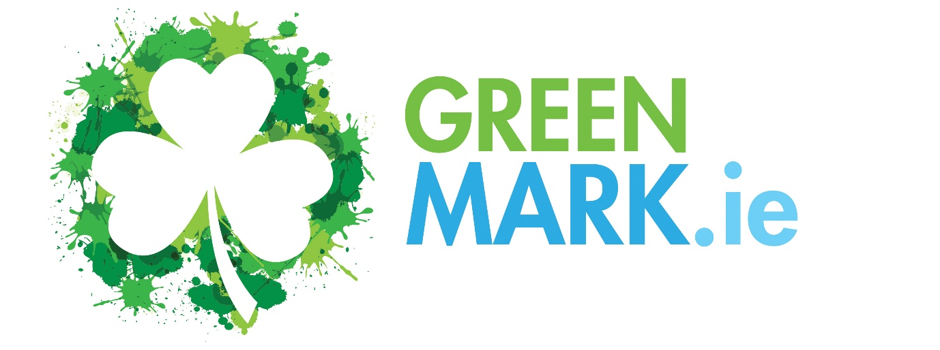

An Environmental Sustainability
Micro-Certification Programme
for Smaller Businesses

Information and Application Form

GREENMark & GREENMark Eco-Label
Small Business Environmental Sustainability - Micro-Certification

Most small businesses operate in a responsible and sustainable manner but are not formally certified or a member of a recognised sustainability programme. Irish tourism businesses on the Island of Ireland are being “encouraged” by the national tourism agencies to become 3rd party recognised – so that Ireland can be promoted as a sustainable destination.
The GREENMark was initially developed to enable small/micro tourism businesses to formally implement several sustainability standards within their business so that they could use the GREENMark as a micro-certification label to communicate these actions easily to customers.
We have adapted the GREENMark to enable small tourism businesses to meet the minimum required sustainability standards promoted by these national agencies and as a base to allow businesses to achieve higher award standards, if they wish to do so, or are required to as a business imperative.
The GREENMark is a micro-certification environmental sustainability programme that is easy to implement and includes all the tools and supports you need to achieve the GREENMark
There are 20 Standards that are required with c. 28 specific actions, and you will need to show how they have been implemented within your business and, most importantly, how you communicate them to your customers – through your website and within your business. A summary sheet listing the standards is available here.
The standards support many UN Sustainability Development Goals (SDG’s) for tourism businesses
How difficult is the GREENMark to implement? We have designed the GREENMark to be clear and relatively straightforward to implement within any small business. It requires commitment from the owner/management and a “Green” Leader who will drive implementation. It should take no more than 10-20 weeks to implement and there is excellent support available through our online programme website.

What is the difference between the GREENMark and the GREENMark Eco-Label?
The GREENMark Eco-Label is a micro-certification environmental sustainability programme that is easy to implement and includes all the tools and supports you need to achieve the GREENMark
The GREENMark Eco-Label requires members to provide GM with extensive backup information and includes a more stringent audit process. It also costs more per annum to maintain. It is strongly aligned to the Green Hospitality Eco-Label and those members who achieve it will also qualify as a GHP Eco-Label business.
The GREENMark Eco-Label is designed for Accommodation (and other) tourism businesses that have a presence on online booking engines such as booking.com, Expedia.com, Google.com where they use a Sustainability Certified filter. Securing the GREENMark Eco-Label delivers a competitive advantage to these accommodation businesses – if you are not listed your business will disappear from the searches when it is selected!
Some businesses who are not listed online may also wish to secure the GREENMark Eco-Label as they wish to demonstrate a more robust sustainability system when engaging with customers.
The choice is yours – if you are listed in any online accommodation booking engine you should be planning for the GREENMark Eco-Label but could start with the simple GREENMark and then progress to the Eco-Label as you expand your knowledge and capabilities.
The GREENMark Eco-Label implementation, reporting and auditing requirements have been enhanced to comply with the EU Green Claims Directive which comes into force at the end of 2026 and additional changes may be made to ensure that it is in compliance with these requirements. Any updates will be noted in the Programme Updates on the GREENMark Web Portal platform.

Applying for the GREENMark. What do I do next?
Make an application using the application form enclosed and identify that you wish to achieve the GREENMark
We will raise an initial registration invoice for €299 plus VAT
Once you have paid the initial invoice, we will give you access to the GREENMark online platform which provides all you need to implement the standards and achieve the GREENMark
Using our bespoke Green Track, when you notify us that you have implemented 100% of the Standards, we will conduct a Desk Audit to confirm that the standards have been implemented, and that the quality of their implementation achieves the minimum quality score required
- If the Audit identifies that any standard has not been implemented and/or to a satisfactory quality level, you will receive an audit report identifying where you need to improve and will be entitled to a follow up desk audit on the standards highlighted as per the T&C’s
- If you fail to achieve recognition after the 2nd desk audit and wish to proceed you will be required to pay an additional audit fee of €299
- Following a successful audit, we will advise you and invoice you for your first year’s membership fee and your certified membership renewal starts from that date.
- On receipt of payment, we will issue you with your certificate and logo and provide a marketing document for completion
- An audit fee of €299 is payable every 3 years to enable you to retain the GREENMark and an annual membership fee based on your utility costs.
(The GREENMark is only available for businesses with Annual Utility Costs of less than €100,000 per annum. A review audit will take place every 3 years and will be charged for at a cost of €299, additional to the annual membership fees)
(Businesses with spends of over €100,000 who require support/certification should become a Green Hospitality Programme member – find us at www.greenhospitality.ie)

Applying for the GREENMark Eco-Label. What do I do next?
Make an application using the application form enclosed and identify that you wish to achieve the GREENMark Eco-Label
We will raise an initial registration invoice for €299 plus VAT
Once you have paid the initial invoice, we will give you access to the GREENMark online platform which provides all you need to implement the standards and achieve the GREENMark Eco-Label
Using our bespoke Green Track, when you notify us that you have implemented 100% of the Standards, we will conduct a Desk Audit to confirm that the standards have been implemented, and that the quality of their implementation achieves the minimum quality score required. (An audit fee is required for those looking to achieve the GREENMark Eco-Label – The cost is €500 and must be paid in advance)
- You will provide GREENMark access to the documents that show how you have implemented each standard using a file sharing programme.
- If the Audit identifies that any standard has not been implemented and/or to a satisfactory quality level you will receive an audit report identifying where you need to improve and will be entitled to a follow up desk audit on the standards highlighted as per the T&C’s
- If you fail to achieve the Eco-Label after the follow up desk audit and wish to proceed you will be required to pay an additional audit fee of €500
- Following a successful audit, we will advise you and invoice you for your first year’s membership fee which is based on your annual utility costs.
- On receipt of payment, we will issue you with your certificate and logo and provide a marketing document for completion
(The GREENMark Eco-Label is only available for businesses with Annual Utility Costs of less than €100,000 per annum. An audit will take place every 3 years and will be charged for, additional to the annual membership fees)
(Businesses with spends of over €100,000 who require support/certification should become a Green Hospitality Programme member – find us at www.greenhospitality.ie)
(Larger businesses can become GREENMark Eco-Label members and implement the standards as an initial step towards a higher 3rd party certification programme suitable for their business but will be required to switch to the full Green Hospitality Programme as part of their application to be audited)

Eco-Friendly Business GREENMark
Annual Membership Costs
Size of Business | Explanation | GREENMark Annual Cost* | GREENMark Eco-Label Annual Cost*
Micro | B&B’s and small self-catering operations, Activity providers and smaller attractions, Artisan food producers, artisan craft producers, others, etc.  (Spends less than €25,000 pa on utilities) | €199 | €399
Small | Guesthouse, Hostel, Restaurant, Pub – Larger self-catering, Activity/Attraction providers, local attractions, others, etc.  (Spends less than €50,000 pa on utilities) | €249 | €449
Medium | Larger guesthouses & hostels, self-catering villages and camping sites, larger attractions and activity providers and Regional Attractions, Others, etc.  (Spends less than €75,000 pa on utilities) | €299 | €499
Larger | Larger accommodation providers and larger attractions – Small Hotels, Hostels, large self-catering and camping sites – Attractions of a National scale, Green Tour Operators, others, etc.  (Spends less than €100,000 pa on utilities) | €349 | €549

*(Pricing is based on the size of your business and/or your total annual utility costs - The total cost of your energy, water and waste)
(Businesses that spend more than €100,000 pa on utilities should contact us to discuss serious cost saving opportunities and should be planning to achieve certification through the Green Hospitality Programme) VAT @ the current rate will be added
Prices are for one year’s listing and are payable annually to retain the GREENMark and must be paid within 30 days of receipt of invoice – failure to pay will result in immediate removal as a micro-certified business from all listings and will incur a re-listing charge.
Whilst the business explanations above mention specific types of tourism and hospitality businesses, this programme is open to all businesses that wish to be recognised for their environmental activities and can also be an entry point to the Green Hospitality Awards certification.

Terms & Conditions

- Every member agrees to abide by the terms and conditions of the GREENMark programme.
- Each business will commit to operating their business in a responsible environmental manner and to maintain the standards set by the GREENMark and any other environmental standards set/required within their business sector and will formally review their standards implementation at least annually.
- Each business must create a “Green” page on their website where they clearly communicate their environmental actions and provide links to the GREENMark website
- Companies must provide GREENMark with required marketing information
- Payment of audit or annual fee must be made within 30 days of its due date
- GREENMark may require businesses to implement additional standards if GREENMark deems them necessary
- Conditions may vary from time to time and will be noted on the GREENMark webpages.
- An audit fee is payable every 3 years

The GREENMark reserves the absolute right to refuse any business a listing and to remove any business listed if GREENMark considers the business is not providing or delivering a sustainable or environmentally beneficial product/service. By applying for certification, companies fully accept these terms and conditions and any changes GREENMark may make to those Terms & Conditions at any time. Businesses may ask for their product/service to be removed from GreenTravel.ie at any time – no refunds are possible.

APPLICATION FORM
I wish to apply for the:
GREENMark
GREENMark Eco-Label
Business Details:
Name of Business:
Name of Owner/ Manager:
Email:
Type of Business:
Address:

Website:
How much do you spend each year on Energy, Water and Waste Disposal? €

Your Name:
Your Email:
Your Position:
Signature:
Date:
PO Number: (If Required):
(Please note that your initial membership fee must be paid before access to the programme is granted)
SEND THIS COMPLETED FORM TO: INFO@GREENMARK.IE

